**SHOPMAP**

**A PROJECT REPORT**

**Submitted By**

**BABLI PANDEY**

**University Roll No 1900290140012**

**Submitted in fulfillment of the**

**Requirements for the Degree of**

**MASTER OF COMPUTER APPLICATIONS**

**Under the Supervision of**

**Ms. NEELAM RAWAT**

### ASSOCIATE PROFESSOR



**Submitted to**

**Department Of Computer Applications**

**KIET Group of Institutions, Ghaziabad**

**Uttar Pradesh-201206**

**(June 2022)**



**DECLARATION**

I hereby declare that the work presented in this report entitled “SHOPMAP’’, was carried out by me. I have not submitted the matter embodied in this report for the award of any other degree or diploma of any other University or Institute.

I have given due credit to the original authors/sources for all the words, ideas, diagrams, graphics, computer programs, experiments, results, that are not my original contribution. I have used quotation marks to identify verbatim sentences and given credit to the original authors/sources.I affirm that no portion of my work is plagiarized, and the experiments and results reported in the report are not manipulated. In the event of a complaint of plagiarism and the manipulation of the experiments and results, I shall be fully responsible and answerable.

**CERTIFICATE**

Certified that **Babli Pandey (Enrollment No. 1900290140012)** have carried out the project work having “ **SHOPMAP**” for Master of Computer Applications from Dr. A.P.J. Abdul Kalam Technical University (AKTU**)**, Technical University, Lucknow under my supervision. The project report embodies original work, and studies are carried out by the student himself/herself and the contents of the project report do not form the basis for the award of any other degree to the candidate or to anybody else from this or any other University/Institution.

**Date:**

**Babli Pandey**

**University Roll No. 1900290140012**

This is to certify that the above statement made by the candidate is correct to the best of my knowledge.

Date:

**Ms. Neelam Rawat**

**Associate Professor**

**Department of Computer Applications**

**KIET Group of Institutions, Ghaziabad**

**Signature of External Examiner Signature of Internal Examiner**

**Dr. Ajay Shrivastava**

**Head, Department of Computer Applications**

**KIET Group of Institutions, Ghaziabad**

**ABSTRACT**

Through SHOPMAP we try to build cutting edge for retail and manufacturing for small ans medium businesses to put them back at the centre of indian economy

React.js is the most popular front-end JavaScript library for building Web applications.

React.js or Reactjs or simply React are different ways to represent React.js. Most fortune 500 companies use Reactjs  In this article, we will learn what React.js (or simply React or Reactjs) is and why we should use Reactjs instead of other JavaScript frameworks like Angular. Node.js is a rapidly growing technology that has been overtaking the world of server-side programming with surprising speed. MongoDB is a technology that’s revolutionizing database usage. Together, the two tools are a potent combination, thanks to the fact that they both employ JavaScript and JSON.

**ACKNOWLEDGEMENT**

Success in life is never attained single handedly. My deepest gratitude goes to my thesis supervisor, **Ms. Neelam Rawat** for her guidance, help and encouragement throughout my research work. Their enlightening ideas, comments, and suggestions.

Words are not enough to express my gratitude to **Dr. Ajay Kumar Shrivastava, Professor and Head, Department of Computer Applications**, for his insightful comments and administrative help at various occasions.

Fortunately, I have many understanding friends, who have helped me a lot on many critical conditions.

Finally, my sincere thanks go to my family members and all those who have directly and indirectly provided me moral support and other kind of help. Without their support, completion of this work would not have been possible in time. They keep my life filled with enjoyment and happiness.

**Babli Pandey(1900290140012)**

**TABLE OF CONTENTS**

|  |
| --- |
|  |
| * Certificate |
| * Abstract |
| * Acknowledgement |
|  |
| **CHAPTER 1: INTRODUCTION** |
| 1.1 Project Title & Description |
| 1.2 Project scope |
| 1.3 H/w, S/w used in project |
| 1.4 Project schedule |
|  |
| **CHAPTER 2: Technical Feasibility** |
| 2.1 Technical feasibility |
| 2.2 Technology Description |
| 2.3 Technology used in project |
|  |
| **CHAPTER 3: Backend Design** |
| 3.1 Data Dictionary |
| 3.2 ER Diagram and/or DFD |
| 3.3 Database design/ database tables |
|  |
| **CHAPTER 4: Frontend Design** |
| 4.1 Input / Output Form (Screenshot) |
|  |
| **CHAPTER 5: Report** |
| 5.1 Report Output (Screenshot) |
| **CHAPTER 6: Testing** |
| 6.1 Test Case (Screenshot) |
|  |
| **CHAPTER 7: LIMITATION** |
| 7.1 Limitation  7.2 Future scope |
| 1.3 Future Enhancement |
|  |
| **CHAPTER 8: CONCLUSION** |
| **CHAPTER 9: REFERENCES** |

**CHAPTER-1**

**INTRODUCTION**

**1.1 PROJECT TITLE:**

**ShopMap**( shopmap.leadbox.ai )

Building cutting edge solutions for retail and manufacturing Small and Medium Businesses(SMBs) to put them back at the centre of the Indian economy.

Our project provides solution to small and medium businesses and bring them to online platform.

Provide simple and reliable communication channel between customers and local retail shops.

Find local stores based on product searches from online stores and current location.

Help customers to compare online product prices with local stores.

People can look online for prices of products on Amazon, Flipkart, or other e-commerce Stores, but not otherwise.

People can only check best deals in online available e-commerce stores but not otherwise – Some products need product quality verification by visiting store. Some products are available cheaper in local stores than online stores but we don’t have mechanism in current time to compare.Some products are available cheaper in local stores than online stores but we don’t have mechanism in current time to compare.All local retail shops are not on online platforms, because of this local retail shops do not have good reach out to their customers, also cannot offer latest deals and updated prices to customers.

**PROJECT DESCRIPTION:**

Shopmap contains information of all products which are in range of 10 to 15 km shops. In this project we compare all the amazon , flipkart etc products with the local markets in terma of their price and quality.

This project contains various features like shop owner can make catalogue of all products and schedule an event. Shop owner can chat with the customers through its online dashboard.

Customer can only check best deals in online available e-commerce stores but not otherwise – Some products need product quality verification by visiting store. Some products are available cheaper in local stores than online stores but we don’t have mechanism in current time to compare.Some products are available cheaper in local stores than online stores but we don’t have mechanism in current time to compare.All local retail shops are not on online platforms, because of this local retail shops do not have good reach out to their customers, also cannot offer latest deals and updated prices to customers.

One of the main features of shopmap is that we have a bot which acts as a assistant for the customer which helps the customer to select the proper price reasonable product .

Each bot has some rules assigned to it according to the customer for example if customer want to chat with a bot which knows about a specific language

**1.2 PROJECT SCOPE**

Bringing Retailers to the E-commerce game by helping them have their own store, not a separate store or website rather an AI bot enabled Whatsapp Commerce store.

Consolidate store information and product listing from each shop. Customers can then compare prices based on location, delivery time, etc. And redirect the user to Shop’s Whatsapp

chat where the customer can place an order using the Whatsapp Cart option, or talk to the shop owner.

The WhatsApp Business solution will be connected with an AI chatbot to help in the following-

* Help scale operations by helping customers get better answers.
* Bot solution will help integrate with other solutions such as Finance Management System Provide personalized shopping assistant**.**
* Some products are available cheaper in local stores than online stores but we don’t have mechanism in current time to compare.
* To turn traffic into revenue, a digital marketer should also be skilled in Web design. This is essential not only to bring a positive impression toward the brand but to help generate the best conversion as well.
* Seamless shopping experience
* Marketing capability for Shop Owners - Broadcast campaign
* Personal Shopping assistant
* Webstore plugins for Customer

**1.3 Hardware / Software used in Project**

**Hardware Requirement**

We have used following hardware devices for shopmap.

1. **ESP Controllers**

ESP controllers are the conductors of the application and they orchestrate the application's logic and responses to client requests. Via action functions, they receive client requests and generate appropriate responses, mutating the applications data model as required.

2 **Barcode scanner.**

Companies use barcode scanners to capture and read information contained in a barcode. A scanner consists of a light source, a lens and a light sensor that translates optical impulses into electrical ones.

A barcode scanner works by directing a beam of light across the barcode and measuring the amount of light that is reflected. The dark bars on the barcode reflect less light than the white spaces between them. The scanner then converts the light energy into electrical energy, which the decoder then converts into data and forwards to a computer.

**Software Requirement :**

We have used following software technologies and third parties software in shopmap.

* **Oracle VM VirtualBox**

Oracle VM VirtualBox is cross-platform virtualization software thatallows users to extend their existing computer to run multiple operating systemsat the same time. Designed for IT professionals and developers, Oracle VMVirtualBox runs on Microsoft Windows, Mac OS X, Linux, and Oracle Solaris systems and is ideal for testing, developing, demonstrating, and

deploying solutions across multiple platforms on one machine.Oracle VM VirtualBox has been

designed to take advantage of the innovations introduced in the x86 hardware platform, and it is lightweight and easy to install and use. Yet under the simple exterior lies an extremely fast and powerful virtualization engine. With a well earned reputation for speed and agility, Oracle VM VirtualBox contains innovative features to deliver tangible business benefits: excellent performance; a powerful virtualization system; and a

wide range of supported guest operating system platforms.VirtualBox is used to setup the virtual NodeJS servers.

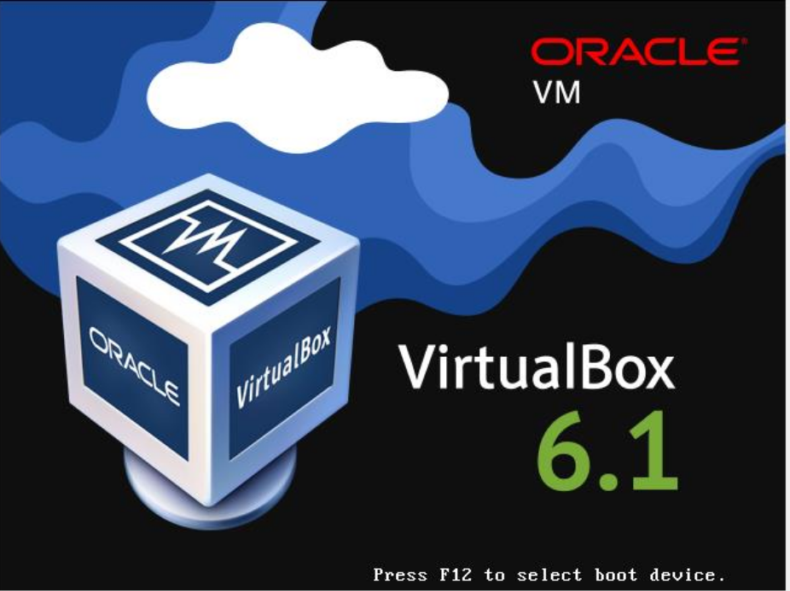 Fig. 1.1 ORACLE VIRTUALBOX

* **CentOS (Operating System)**

CentOS is a community-driven free software effort that provides two Linux distribution (CentOS Linux and CentOS Stream) and a variety of Special Interest Groups releasing packages to run on those distributions. CentOS Linux provides a free, community-supported computing platform functionally compatible with its upstream source, Red Hat Enterprise Linux (RHEL).CentOS Stream is a continuously delivered distribution that tracks just ahead of RHEL and acts as an upstream for RHEL development.

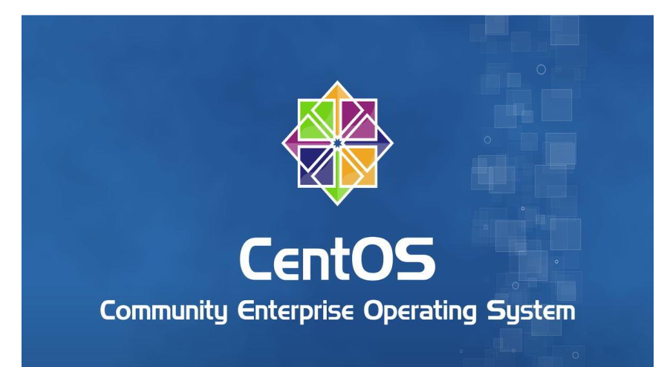 Fig. 1.2 CENTOS

* **ReactJS for front-end development**

React is a JavaScript-based UI development library. Facebook and an open-source developer community run it. Although React is a library rather than a language, it is widely used in web development. The library first appeared in May 2013 and is now one of the most commonly used frontend libraries for web development.

React offers various extensions for entire application architectural support, such as Flux and React Native, beyond mere UI.

**Why React?**

React’s popularity today has eclipsed that of all other front-end development frameworks. Here is why:

Easy creation of dynamic applications: React makes it easier to create dynamic web applications because it requires less coding and offers more functionality, as opposed to JavaScript, where coding often gets complex very quickly.

Improved performance: React uses Virtual DOM, thereby creating web applications faster. Virtual DOM compares the components’ previous states and updates only the items in the Real DOM that were changed, instead of updating all of the components again, as conventional web applications do.

Reusable components: Components are the building blocks of any React application, and a single app usually consists of multiple components. These components have their logic and controls, and they can be reused throughout the application, which in turn dramatically reduces the application’s development time.

Unidirectional data flow: React follows a unidirectional data flow. This means that when designing a React app, developers often nest child components within parent components. Since the data flows in a single direction, it becomes easier to debug errors and know where a problem occurs in an application at the moment in question.

Small learning curve: React is easy to learn, as it mostly combines basic HTML and JavaScript concepts with some beneficial additions. Still, as is the case with other tools and frameworks, you have to spend some time to get a proper understanding of React’s library.

It can be used for the development of both web and mobile apps: We already know that React is used for the development of web applications, but that’s not all it can do. There is a framework called React Native, derived from React itself, that is hugely popular and is used for creating beautiful mobile applications. So, in reality, React can be used for making both web and mobile applications.

Dedicated tools for easy debugging: Facebook has released a Chrome extension that can be used to debug React applications. This makes the process of debugging React web applications faster and easier.

The above reasons more than justify the popularity of the React library and why it is being adopted by a large number of organizations and businesses. Now let’s familiarize ourselves with React’s features.



Fig. 1.3 React Logo

* **NodeJS for Back-end development-**

Node.js is a server-side platform built on Google Chrome's JavaScript Engine (V8 Engine). Node.js was developed by Ryan Dahl in 2009 and its latest version is v0.10.36. The definition of Node.js as supplied by its official documentation is as follows −

Node.js is a platform built on Chrome's JavaScript runtime for easily building fast and scalable network applications. Node.js uses an event-driven, non-blocking I/O model that makes it lightweight and efficient, perfect for data-intensive real-time applications that run across distributed devices.

Node.js is an open source, cross-platform runtime environment for developing server-side and networking applications. Node.js applications are written in JavaScript, and can be run within the Node.js runtime on OS X, Microsoft Windows, and Linux.

Node.js also provides a rich library of various JavaScript modules which simplifies the development of web applications using Node.js to a great extent.

Node.js = Runtime Environment + JavaScript Library

Features of Node.js

Following are some of the important features that make Node.js the first choice of software architects.

Asynchronous and Event Driven − All APIs of Node.js library are asynchronous, that is, non-blocking. It essentially means a Node.js based server never waits for an API to return data. The server moves to the next API after calling it and a notification mechanism of Events of Node.js helps the server to get a response from the previous API call.

Very Fast − Being built on Google Chrome's V8 JavaScript Engine, Node.js library is very fast in code execution.

Single Threaded but Highly Scalable − Node.js uses a single threaded model with event looping. Event mechanism helps the server to respond in a non-blocking way and makes the server highly scalable as opposed to traditional servers which create limited threads to handle requests. Node.js uses a single threaded program and the same program can provide service to a much larger number of requests than traditional servers like Apache HTTP Server.

No Buffering − Node.js applications never buffer any data. These applications simply output the data in chunks.

License − Node.js is released under the MIT license.

Who Uses Node.js?

Following is the link on github wiki containing an exhaustive list of projects, application and companies which are using Node.js. This list includes eBay, General Electric, GoDaddy, Microsoft, PayPal, Uber, Wikipins, Yahoo!, and Yammer to name a few.

Projects, Applications, and Companies Using Node

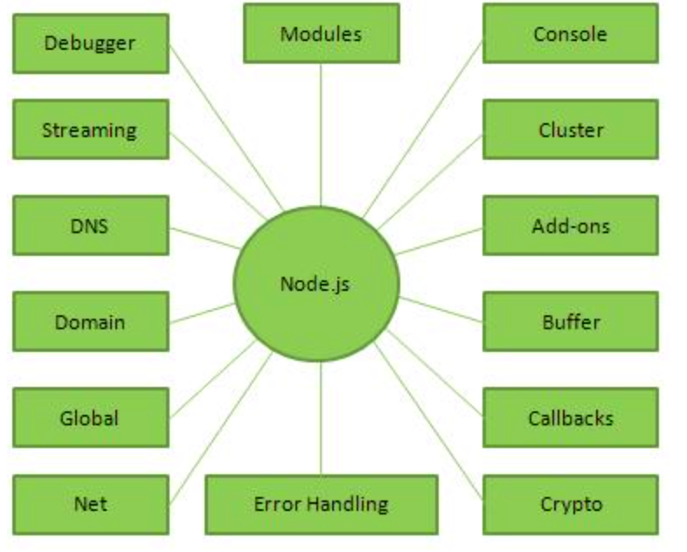 Fig. 1.4 Components for Node

* **Mongo-DB (No SQL DataBase)**

MongoDB is a non-relational document database that provides support for JSON-like storage. The MongoDB database has a flexible data model that enables you to store unstructured data, and it provides full indexing support, and replication with rich and intuitive APIs.

AWS enables you to set up the infrastructure to support MongoDB database deployments in a flexible, scalable, and cost-effective manner on the AWS Cloud. AWS also enables you to run MongoDB-compatible workloads with Amazon DocumentDB (with MongoDB compatibility), a fast, scalable, and fully managed non-relational database service. With Amazon DocumentDB

you don’t have to worry about operational hassle including hardware provisioning, backups, upgrades, durability, patching, high availability, and more. As a cloud-native database, Amazon DocumentDB enables you to build applications that can quickly and easily scale with your

workload.

* **Rainforest API For getting product information from E-Com sites**

The real-time Amazon Product Data API you've been looking for. Start free. No manual rules or web-scrapers required. Stay maintenance-free with Rainforest API. AMZ Reviews API. AMZ Seller Offers API. JSON, CSV and HTML output. AMZ 1P, 2P, 3P Offers.

Rainforest API is an API to retrieve data from any Amazon domain worldwide in real-time. You can use Rainforest API to retrieve products, reviews, review comments, offers, lightning deals, category results, search results, also-bought products, seller profiles, seller feedback, seller products, reviewer profile, questions, extended question answers and bestselling products from any Amazon site.

Rainforest API executes requests in real time and returns clean, structured JSON or CSVresults. You can achieve fine-grained control over your request using the request parameters.

Lookup an ASIN by GTIN / ISBN / UPC / EAN

Rainforest API can automatically convert GTIN/ISBN/UPC/EAN codes to ASINs and return product data. For details of how to lookup Amazon product details by GTIN/ISBN/UPC/EAN please see refer to the guide.

Note that Rainforest will cache the GTIN-to-ASIN mapping for 2 months. To force a new GTIN lookup (for example, if you suspect the existing mapping is stale), use the skip_gtin_cache=true request parameter (note that using skip_gtin_cache=true decrements 2 credits from your balance, instead of 1). Customer Zip & Postal Codes Rainforest API allows you to set up zip or postal codes and run your requests in the context of those zipcodes. This is useful for retrieving data from highly localized ASINs such as Amazon Fresh.

View the Customer Zipcodes docs to learn more about setting up customer zipcodes on your account and using them in your requests. Retrieving Bestselling Products on Amazon

**GET/request**

Getting Amazon data with Rainsforest API is as simple as making an HTTP GET request to the request endpoint. The only required parameters areapi_key(sign up for free to get an API key)

and type (which defines the type of Amazon data you'd like to retrieve).

For example, to retrieve Bestselling products (type=bestsellers) for the "memory cards" Amazon Bestsellers page on amazon.com https://www.amazon.com/s/zgbs/pc/516866 the Rainforest API request would be:

https://api.rainforestapi.com/request?api_key=demo&type=bestsellers&url=https://www.amazon.com/s/zgbs/pc/516866

The results of the Bestsellers request are shown below, the bestselling products are within the bestsellers array. For full documentation on Bestsellers results see the Bestsellers Results docs.

**Response JSON Format-**

{

"request_info":{...}

"request_metadata":{...}

"request_parameters":{...}

"bestsellers":[...]

"pagination":{...}

"bestsellers_info":{...}

}

* **WhatsApp APIs**

With more than 75% of adults preferring to do business the same way they communicate with friends and family, through messaging, the time to engage with customers via their preferred channel is now. WhatsApp now has nearly 3 billion users worldwide across 180 countries. And Syniverse CPaaS Concierge gives you the opportunity to take full advantage of a reach that cannot be matched by anyone else.

In this e-book, you’ll learn about the unrivaled power of WhatsApp Business API and Syniverse CPaaS Concierge and gain insight into just how this powerhouse combo can help you connect to the world.

The WhatsApp Business API uses a REST API Architecture with JSON data formats. The API follows the standard HTTP request-response exchange.

**WhatsApp Business API Root Nodes**

|  |  |
| --- | --- |
| **Node** | **Description** |
|  |  |
| [Account](https://developers.facebook.com/docs/whatsapp/on-premises/reference/account) | Register your WhatsApp account |
| [Certificates](https://developers.facebook.com/docs/whatsapp/on-premises/reference/certificates) | Maintain your Certification Authority (CA) certificates for SSL configuration |
| [Contacts](https://developers.facebook.com/docs/whatsapp/on-premises/reference/contacts) | Verify customer phone numbers to generate WhatsApp IDs |
| Health | Check the status of your WhatsApp application |
| media | Upload, delete, and retrieve media |
| message | Send text, media, message templates, and other types of messages |
| metrices | Collect Webapp metrics |
| [Services](https://developers.facebook.com/docs/whatsapp/on-premises/reference/services) | Delete messages from the database |
| Settings | Set your WhatsApp application, profile, and backup and restore settings |
| stats | Collect Coreapp and database stats |
| support | Get help using the WhatsApp Business API |

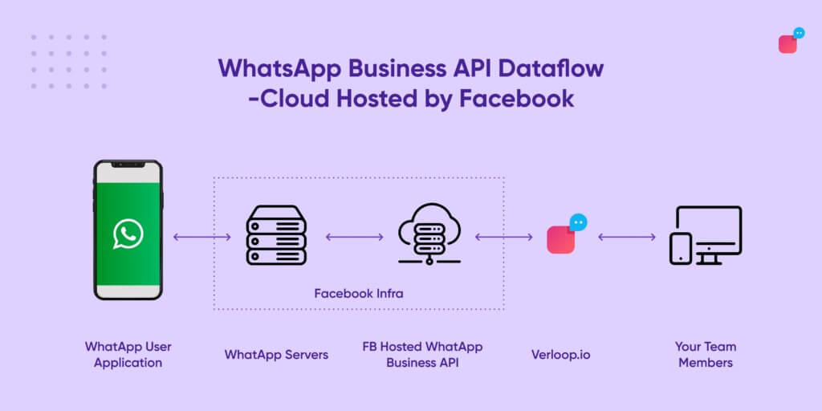 Fig.1.5 Whats API

**1.4 Planning & Scheduling**

# Agile software development

In software development, agile (sometimes written Agile) practices include requirements discovery and solutions improvement through the collaborative effort of self-organizing and cross-functional teams with their customer(s)/end user(s), adaptive planning, evolutionary development, early delivery, continual improvement, and flexible responses to changes in requirements, capacity, and understanding of the problems to be solved.

Popularized in the 2001 Manifesto for Agile Software Development, these values and principles were derived from and underpin a broad range of software development frameworks, including Scrum and Kanban.

While there is much anecdotal evidence that adopting agile practices and values improves the effectiveness of software professionals, teams and organizations, the empirical evidence is mixed and hard to find.

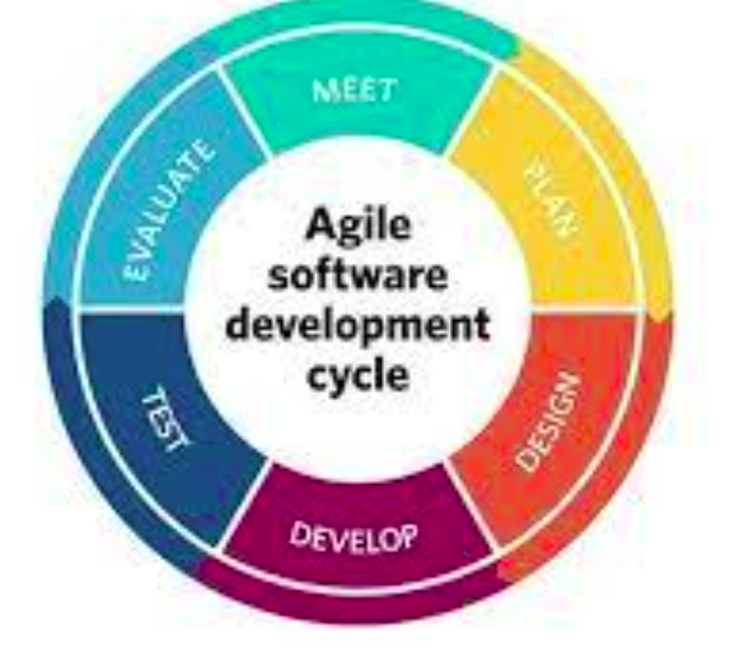

Fig. 1.5 (Azile methodology)

**Gantt chart**

A Gantt chart can be developed for the entire project or a separate chart can be developed for each function. A tabular form is maintained where rows indicate the task with milestones and columns indicate duration (Days).

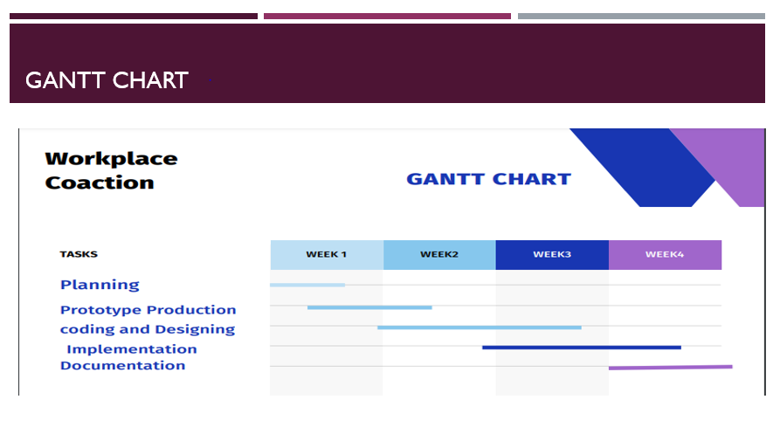

Fig. 2.1: Gantt Chart

* **Software Requirements with specifications**

|  |  |
| --- | --- |
| Name of Components | Specifications |
| Operating system | LINUX, CEntOS |
| Language | HTML,CSS,Javascript, ReactJS,NodeJs, Go Language |
| Software Development kit | NGINX, Google Chrome |
| Markup Language Enable | HTML |

* **Hardware Requirements with specifications**

|  |  |
| --- | --- |
| Name of Components | Specifications |
| Desktop/Laptop | Any Configuration |
| Memory Used | 6.31 MB |

**CHAPTER 2**

**TECHNICAL FEASIBILITY**

**2.1 Technical Feasibility**

**Feasibility study**

After studying and analyzing all the existing and requires functionalities of the system, the next task is to do the feasibility study for the project. Feasibility study includes consideration of all the possible ways to provide a solution to a given problem. The proposed solution should satisfy all the user requirements and should be flexible enough so that future changes can be easily done based on the future upcoming requirements.

**Economical Feasibility**

For the economic feasibility, Economic analysis or cost/benefits analysis is most frequently used technique the effectiveness of a proposed system. it is a procedure to determine the benefits and saving those are expected from the proposes system and compare them with cost .if the benefits outweigh the costs, a decision is taken to design and implement the system. otherwise, further justification or alternative in proposed system will have to be made if it is to have a chance of being approved this is ongoing effort that improves in accuracy at each phase of a system life cycle

**Technical Feasibility**

This included the study of function, performance and constraints that may affect the ability to achieve an acceptable system. For this feasibility study, we studied complete functionalities to be provided in the system, as described in the System Requirement Specification (SRS), and checked if everything was possible using different type of front end and back end platform.

**Operational Feasibility**

No doubt the technically growing world needs more enhancement in technology, this apps is very user friendly and all inputs to be taken all self-explanatory even to a layman. As far our study is concerned, the clients will be comfortable and happy as the system has cut down their loads and bring the young generation to the same virtual world they are growing drastically.

Operational feasibility cover two aspects.one technical performance aspects and the other is acceptance within the organization.

**Operation feasibility determine how the proposed the system will fit in with the current operation and what needs to implement the system.**

Operational feasibility is a measure of how well a proposed system solves the problems, and takes advantage of the opportunities identified during scope definition and how it satisfies the requirements identified in the requirements analysis phase of system development.  
Operational feasibility reviews the willingness of the organization to support the proposed system. This is probably the most difficult of the feasibilities to gauge. In order to determine this feasibility, it is important to understand the management commitment to the proposed project. If the request was initiated by management, it is likely that there is management support and the system will be accepted and used. However, it is also important that the employee base will be acceptingchange.   
The essential questions that help in testing the operational feasibility of a system include the following:

* Does current mode of operation provide adequate throughput and response time?
* Does current mode provide end users and managers with timely, pertinent, accurate and useful formatted information?  
  Does current mode of operation provide cost-effective information services to the business?
* Could there be a reduction in cost and or an increase in benefits?
* Does current mode of operation offer effective controls to protect against fraud and to guarantee accuracy and security of data and information?
* Does current mode of operation make maximum use of available resources, including people, time, and flow of forms?
* Does current mode of operation provide reliable services
* Are the services flexible and expandable?
* Are the current work practices and procedures adequate to support the new system?
* If the system is developed, will it be used?
* Manpower problems
* Labour objections
* Manager resistance
* Organizational conflicts and policies
* Social acceptability

Economic analysis could also be referred to as cost/benefit analysis. It is the most frequently used method for evaluating the effectiveness of a new system. In economic analysis the procedure is to determine the benefits and savings that are expected from a candidate system and compare them with costs. If benefits outweigh costs, then the decision is made to design and implement the system. An entrepreneur must accurately weigh the cost versus benefits before taking .  
Possible questions raised in economic analysis are:

* Is the system cost effective.
* Do benefits outweigh costs.
* The cost of doing full system study
* The cost of business employee time
* Estimated cost of hardware
* Estimated cost of software/software development
* Is the project possible, given the resource constraints?
* What are the savings that will result from the system?
* Cost of employees' time for study
* Cost of packaged software/software development.

The concerned business must be able to see the value of the investment it is pondering before committing to an entire system study.  If short-term costs are not overshadowed by long-term gains or produce no immediate reduction in operating costs, then the system is not economically feasible, and the project should not proceed any further. If the expected benefits equal or exceed costs, the system can be judged to be economically feasible. Economic analysis is used for evaluating the effectiveness of the proposed system.The economical feasibility will review the expected costs to see if they are in-line with the projected budget or if the project has an acceptable return on investment. At this point, the projected costs will only be a rough estimate. The exact costs are not required to determine economic feasibility. It is only required to determine if it is feasible that the project costs will fall within the target budget or return on investment. A rough estimate of the project schedule is required to determine if it would be feasible to complete the systems project within a required timeframe. The required timeframe would need to be set by the organization.

**2.2 Technology Description**

**MERN (MongoDB, ExpressJS, ReactJS, NodeJS)**

A 3-tier architecture is a web app architecture that is widely used around the world. It basically contains 3 tiers: Client, Server, and Database.

**A 3-tier Architecture**

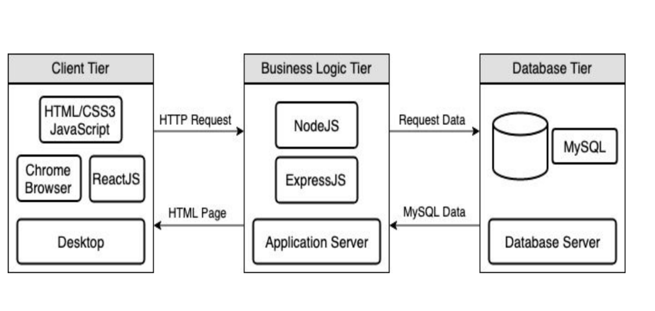 Fig 2.1 Architecture

The architecture of our application is based on a typical MVC model. Our Client tier (View) will be written in Javascript, HTML, and CSS, using ReactJS as the framework. This level of the architecture is what the user will interact with to access the features of our application.

The Business Logic Tier (Controller) will be written using NodeJs and ExpressJS, and this tier represents the Application Server that will act as a bridge of communication for the Client Tier and Database Tier. This tier will serve HTML pages to the user’s device and accept HTTP requests from the user and follow with the appropriate response.

Our Database Tier (Model) will be hosting MongoDB. This is where we will store all of the crucial data our application needs to function.

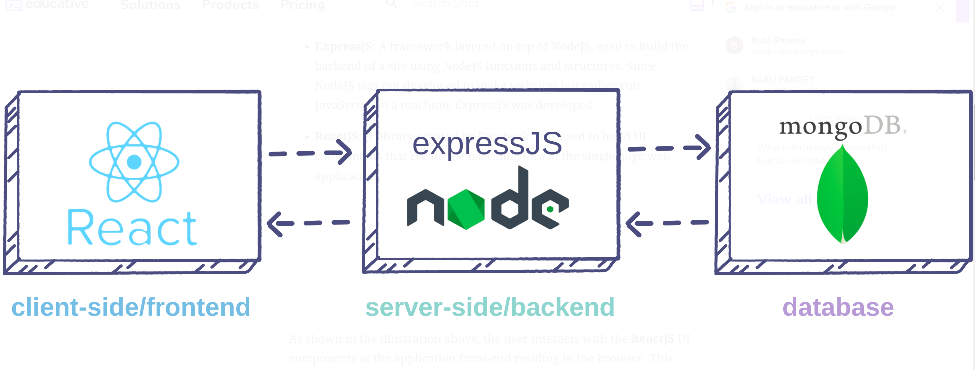

Fig-2.2 MERN Architecture

As shown in the illustration above, the user interacts with the ReactJS UI components at the application front-end residing in the browser. This frontend is served by the application backend residing in a server, through ExpressJS running on top of NodeJS.

Any interaction that causes a data change request is sent to the NodeJS based Express server, which grabs data from the MongoDB database if required, and returns the data to the frontend of the application, which is then presented to the user

**NodeJS:**

Node.js is an open source server environment

* Node.js is free
* Node.js runs on various platforms (Windows, Linux, Unix, Mac OS X, etc.)
* Node.js uses JavaScript on the server

A common task for a web server can be to open a file on the server and return the content to the client.

Here is how React handles a file request:

1. Sends the task to the computer's file system.
2. Waits while the file system opens and reads the file.
3. Returns the content to the client.
4. Ready to handle the next request.

Here is how Node.js handles a file request:

1. Sends the task to the computer's file system.
2. Ready to handle the next request.
3. When the file system has opened and read the file, the server returns the content to the client.

Node.js eliminates the waiting, and simply continues with the next request.

Node.js runs single-threaded, non-blocking, asynchronous programming, which is very memory efficient.

**Notepad++**

Notepad++ is a text and source code editor for use with Microsoft Windows. It supports tabbed editing, which allows working with multiple open files in a single window. The product's name comes from the C increment operator. Notepad++ is distributed as free software

APPLICATION : F5 NGINX.Server, Notepad++

DESIGNING : HTML, CSS, Javascript, ReactJS

BACKEND : NodeJS

**2.3 Technology Used (Designing and Developing)**

This project has been developed Reactjs and Nodejs.

**ReactJs**

* Data binding on a single level.
* Building blocks with a lot of flexibility.
* JavaScript that is [isomorphic](https://stackoverflow.com/questions/43064707/what-does-isomorphic-react-mean).
* There is a lot of support in the community.
* In a single location, you can see and control everything.
* Aids in the development of huge applications.
* It works nicely with component base user Interfaces

**CSS**

* CSS stands for Cascading Style Sheets
* CSS describes how HTML elements are to be displayed on screen, paper, or in other media
* CSS saves a lot of work. It can control the layout of multiple web pages all at once
* External stylesheets are stored in CSS files

**JavaScript**

JavaScript, often abbreviated as JS, is a programming language that conforms to the ECMAScript specification. JavaScript is high-level, often just-in-time compiled and multi-paradigm. It has dynamic typing, prototype-based object-orientation and first-class functions.

**NodeJs**

Node.js is an open source, cross-platform runtime environment for developing server-side and networking applications. Node.js applications are written in JavaScript, and can be run within the Node.js runtime on OS X, Microsoft Windows, and Linux.

Node.js also provides a rich library of various JavaScript modules which simplifies the development of web applications using Node.js to a great extent.

**CHAPTER 3**

**BACKEND DESIGN**

**3.1 DATABASE DESIGN**

For this thread we are using top level system design methodology for following prospective.

1. Secure
2. Scalability
3. Fast for product searching from near by shops
4. Responsive

**i) Secure:**

Node.js is one such technology that developers use for web application development. It is designed to be completely secure. However, while developing any web application through Node.js, you will need to utilize various third-party open-source packages through NPM (Node Package Manager) and unfortunately,  as per a [survey](https://github.com/ChALkeR/notes/blob/master/Gathering-weak-npm-credentials.md), 14% of the NPM ecosystem is vulnerable to security issues, and these indirectly account for 54% of the packages. Ultimately, these vulnerabilities are transferred to Node.js web applications.

Security vulnerabilities are not new for open-source backend frameworks and every Node.js developer understands the risks that hackers can pose for applications and user data. Keeping Node.js security risks in mind, the article would focus on the risks, best practices and tools development teams can utilize for improving their web application security.

**ii) Scalability**

Clustering is a technique used to horizontally scale a Node.js server on a single machine by spawning child processes (workers) that run concurrently and share a single port. It is a common tactic to reduce downtime, slowdowns and outages by distributing the incoming connections across all the available worker processes so that available CPU cores are utilized to their full potential. Since a Node.js instance runs on a single thread, it cannot take advantage of multi-core systems properly - hence the need for clustering.

**iii) fast**

We can see the CPU is consistently at or above 100% as the process works hard to process queued requests. Node’s JavaScript engine (V8) actually uses two CPU cores in this case because the machine is multi-core and V8 uses two threads. One for the Event Loop and the other for Garbage Collection. When we see the CPU spiking up to 120% in some cases, the process is collecting objects related to handled requests.

**iv) Responsive**

If you have ever written a file upload progress bar in web using traditional web platform, trust me it might not have been that elegant, because the client server web programming model is event driven programming of course, but it is a pull based model from client to server. For example, if the client would like to know how much percentage of the file is uploaded so that it can update its progress bar in the browser, client has to keep on poking the server to let the server know the client about the progress of file upload. Imagine if ten thousand clients are asking every time about this file upload status is definitely unnecessary traffic which can be saved if the platform is shifted to Node**.**

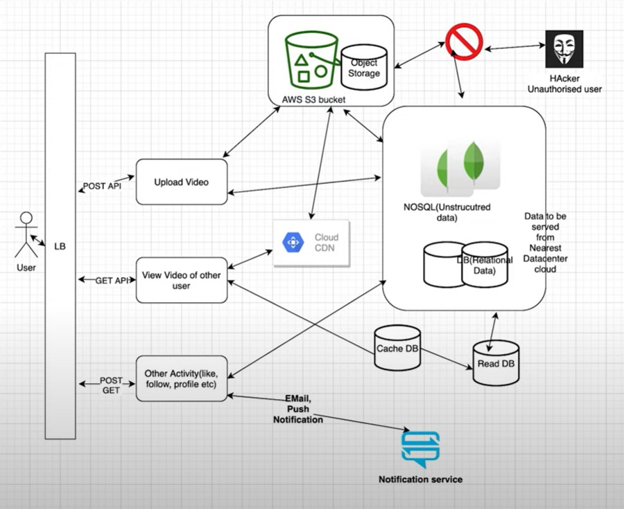

Fig. 3.1: Backend Design

**3.2 Database Collections (MongoDB/NoSQL)**

1. **Users** : For storing users/client details like user_name, email, contact_number, password, user_location...etc.
2. **Products :** It has product information like model number, expiry date, asins number, price, delivery date, current_offers,

offers_on_banks, total amount, category...etc

1. **Stores :** This table has information about all registered stored on shop map site. Column name are – Store ID, Store location, Store name, Store owner name, store category, store type, latitude, longitude.
2. **Product_Catalog:** This table has information about product categories like - sku, id, name, description, short-description, date, categories, tags, image, reviews, stock, weight, dimensions, price, buy.. etc
3. **Chats:** This collection contains the information about customers chats with shop owner like – message_id, customer_id, status, owner_id ,product_name, chat_created_at...ect
4. **History:** This collection contains information about historical purchase of customer so that shop owner can get the information of customer as per their choice and other prospects. Columns are – id, client_id, purchase products, purchase time, location, contact no...etc.
5. **Cashed:** This table is used for storing information about a customer for their latest product purchase.
6. **Active_Users:** This table contains information about current active users logged into shops.

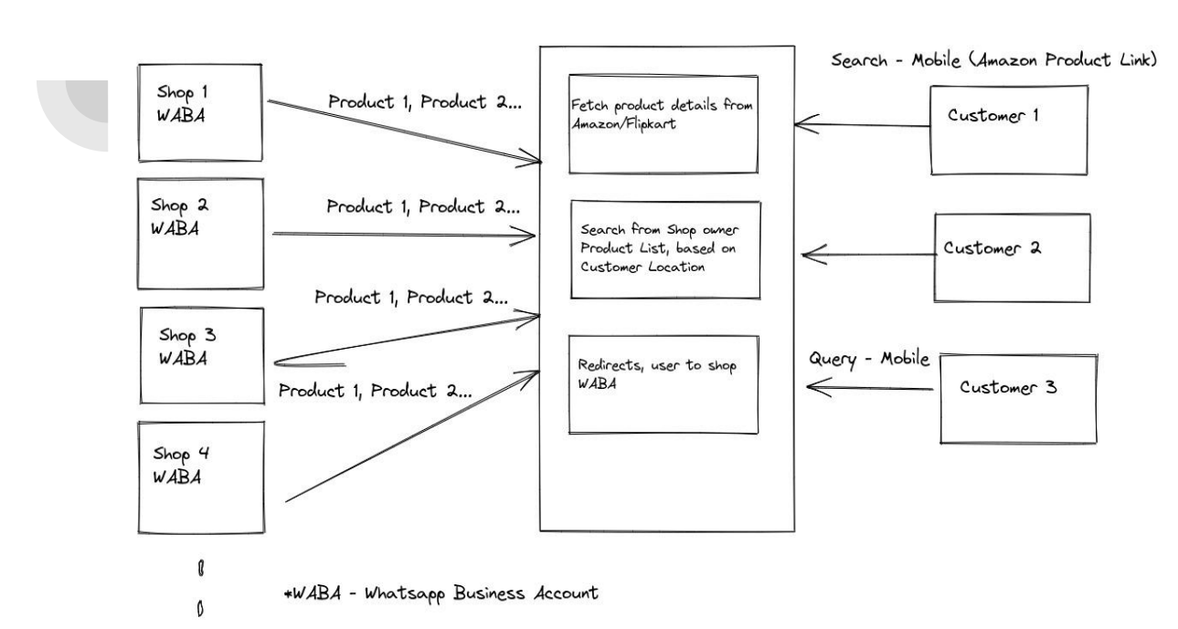

Fig. 3.2: Backend Architecture

**CHAPTER 4**

**FRONTEND DESIGN**

The top level front-end design of shopmap is given below-

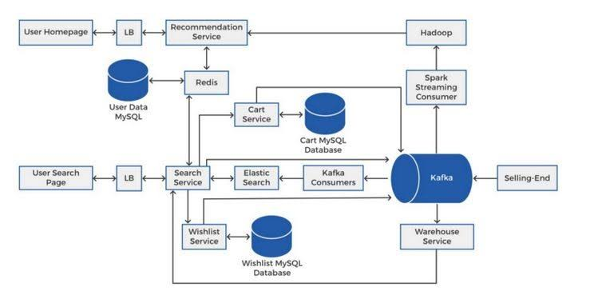 Fig 4.1 Project front-end design

This improve the overall performance of applications by decreasing the burden on servers associated with managing and maintaining application and network sessions, as well as by performing application-specific tasks.

Load balancers are generally grouped into two categories: Layer 4 and Layer 7. Layer 4 load balancers act upon data found in network and transport layer protocols (IP, TCP, FTP, UDP). Layer 7 load balancers distribute requests based upon data found in application layer protocols such as HTTP.

Requests are received by both types of load balancers and they are distributed to a particular server based on a configured algorithm. Some industry standard algorithms are:

* Round robin
* Weighted round robin
* Least connections
* Least response time

**Admin Generated Email and Password**

The application will work with Email and password generated by the admin after joining the firm.

**Delete and Update Employee**

Admin will add, update and delete an employee.

**Register and Login**

To work on the web application one should be registered and should have to login with the organizational email and password.

**4.1 Code snipped-**

**App.jsx**

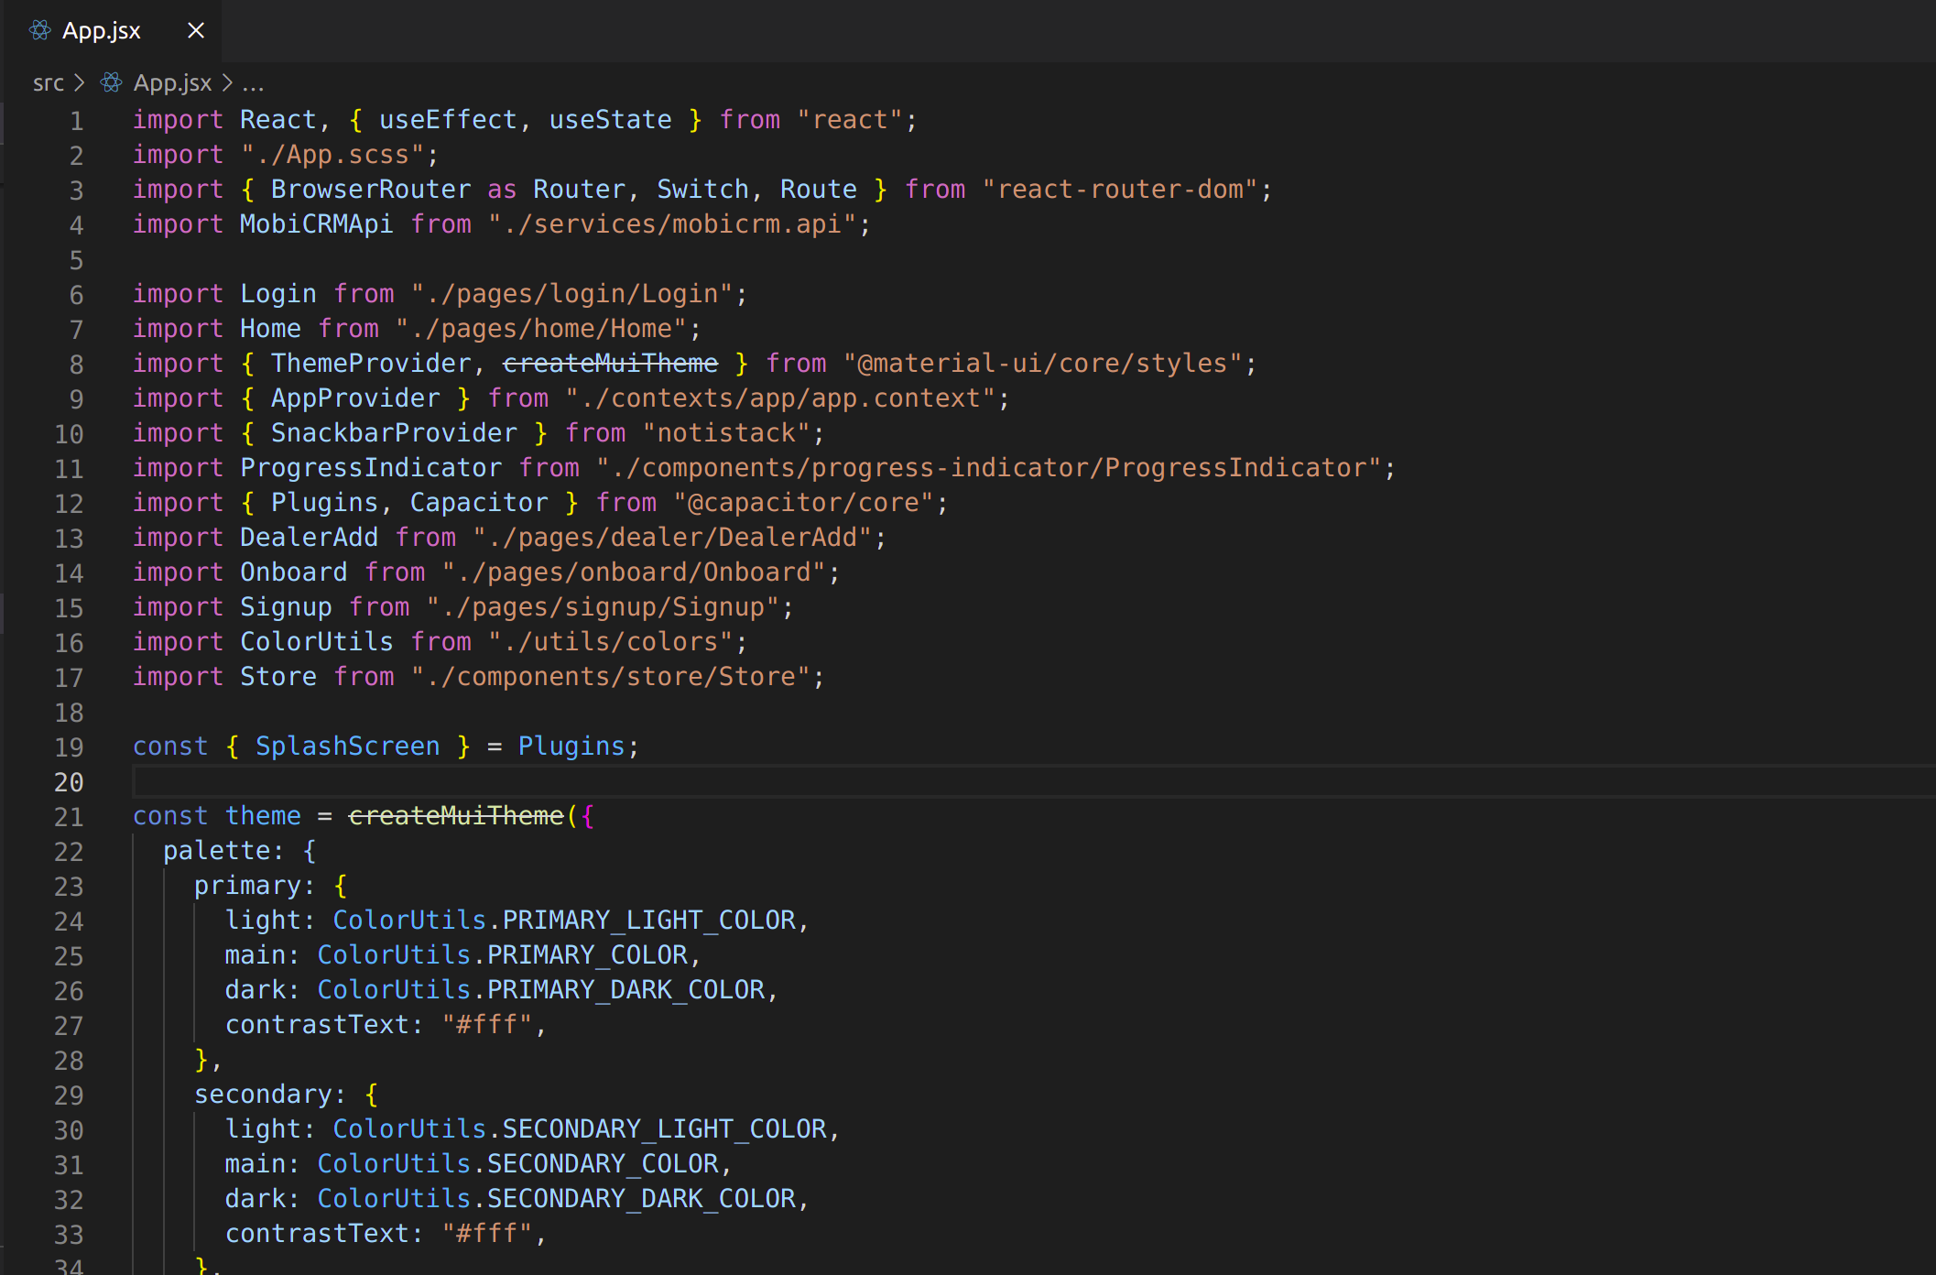

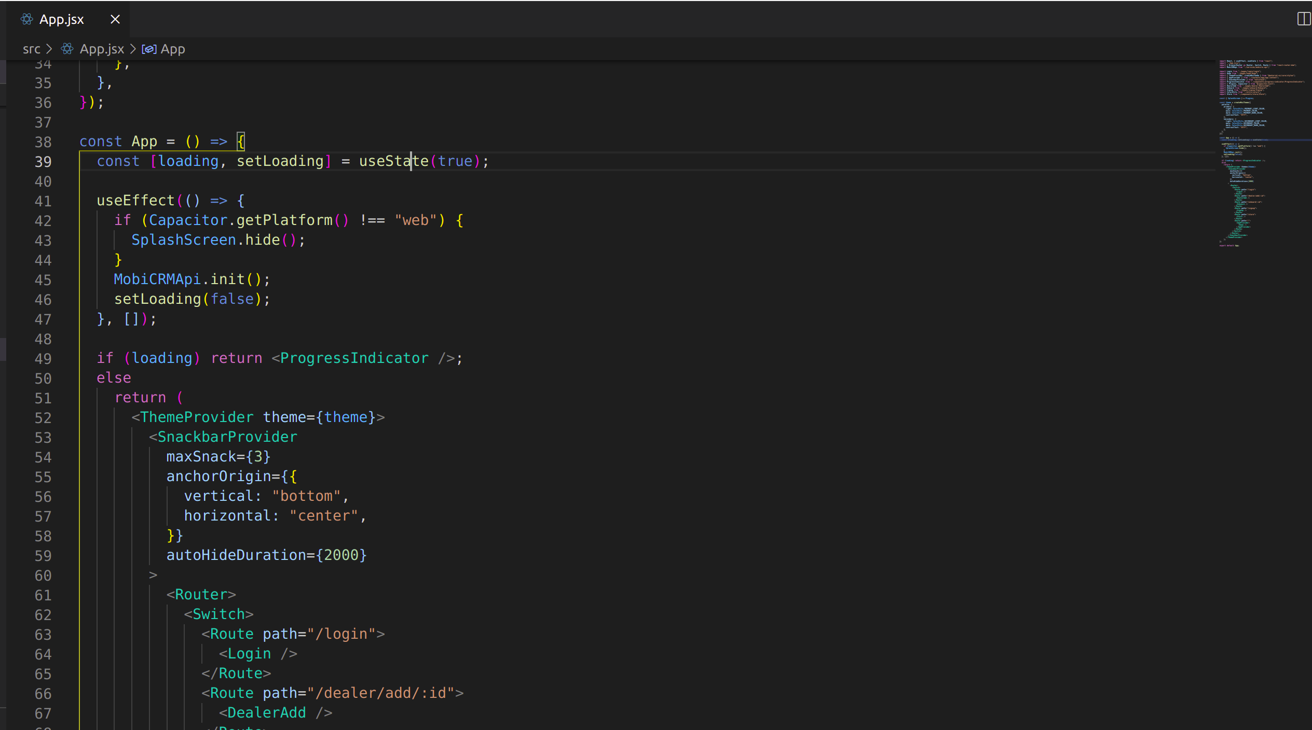

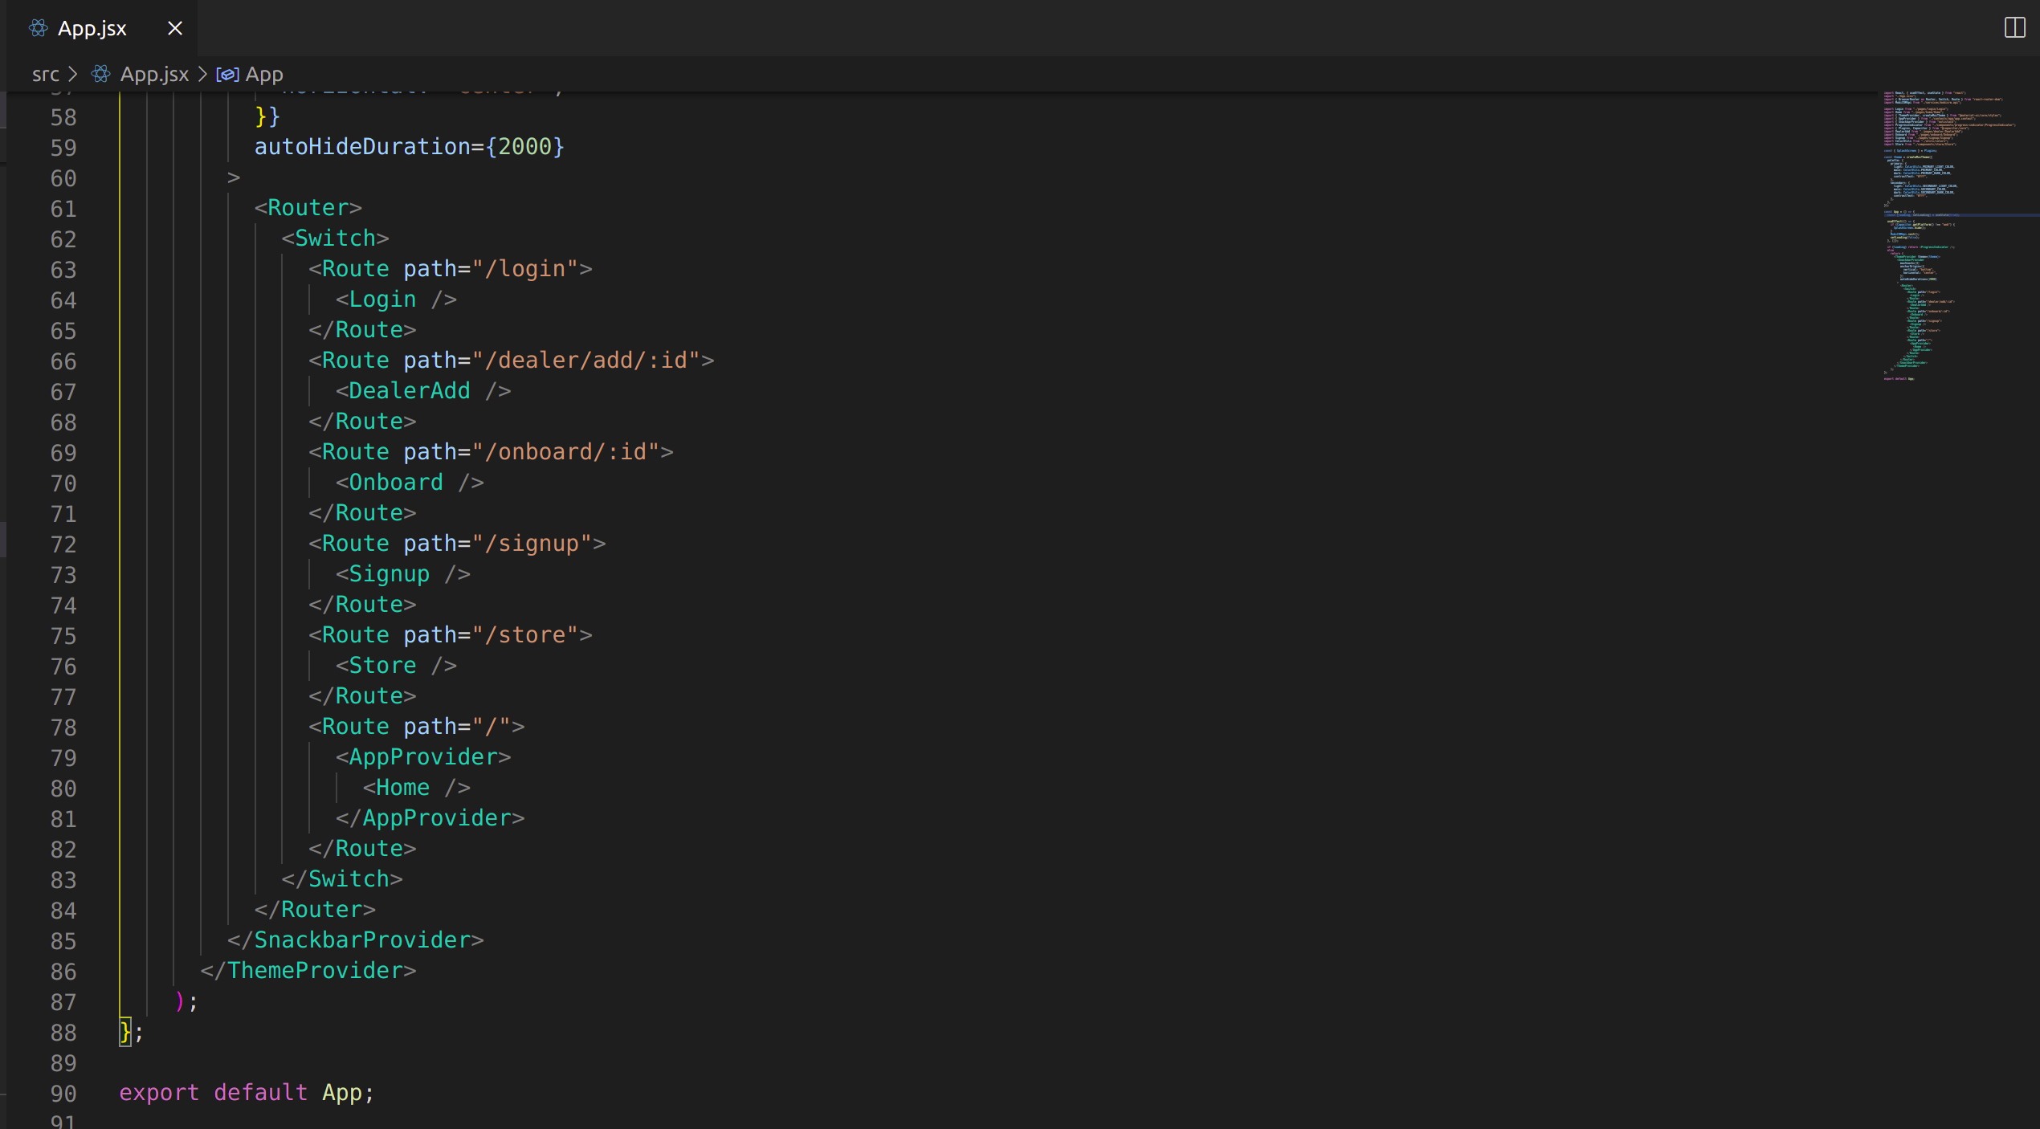

**4.2 Store.js**

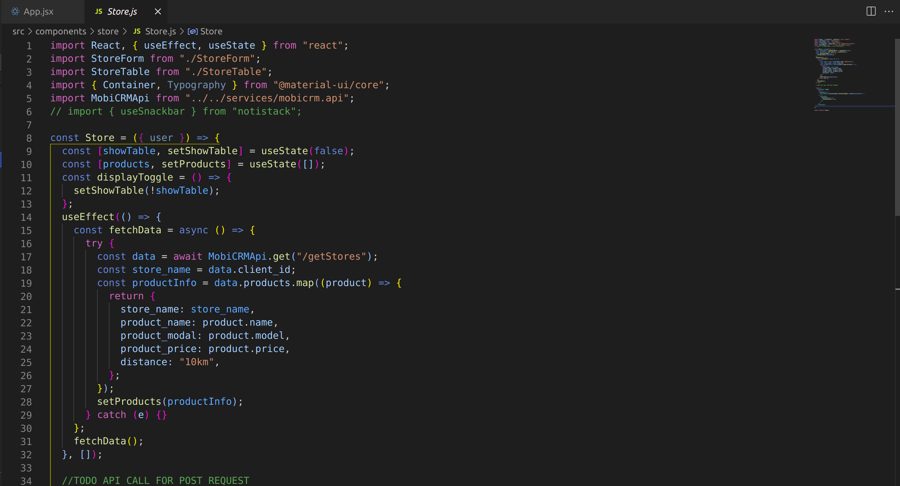

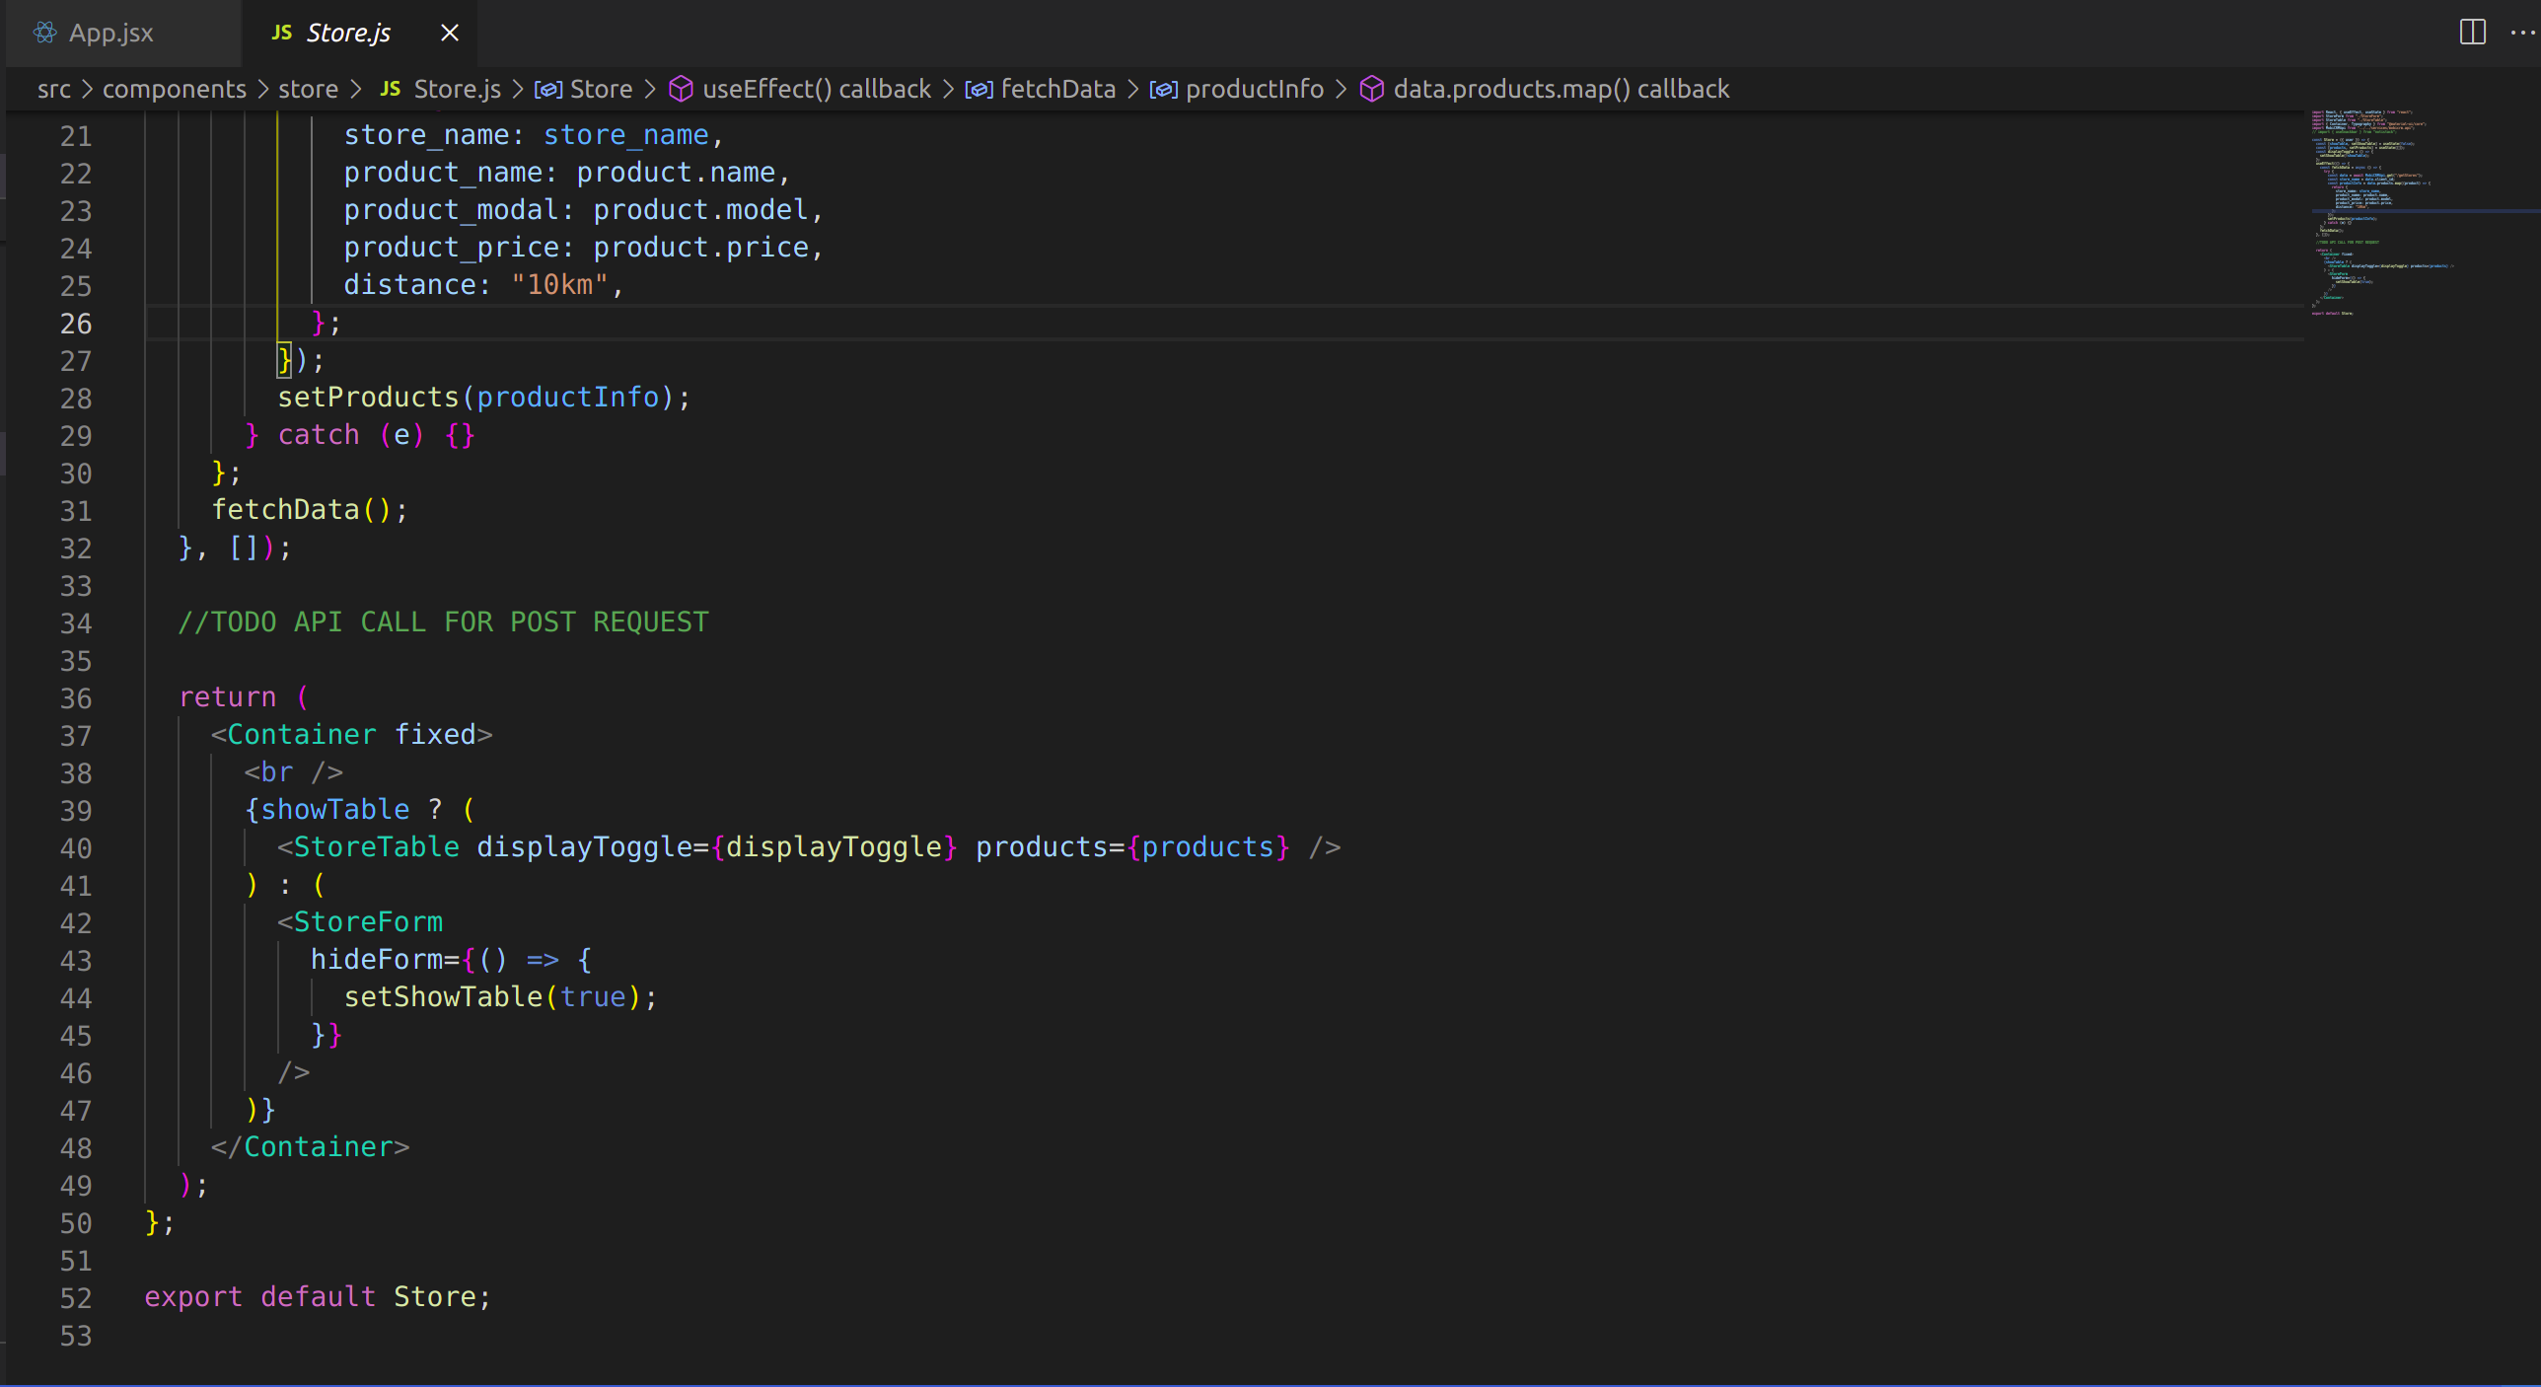

**4.3 StoreForm.js**

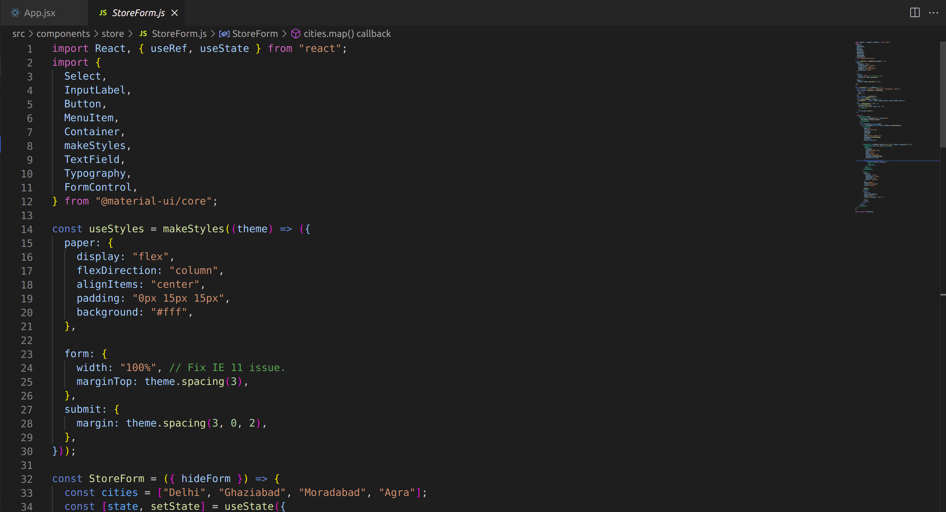

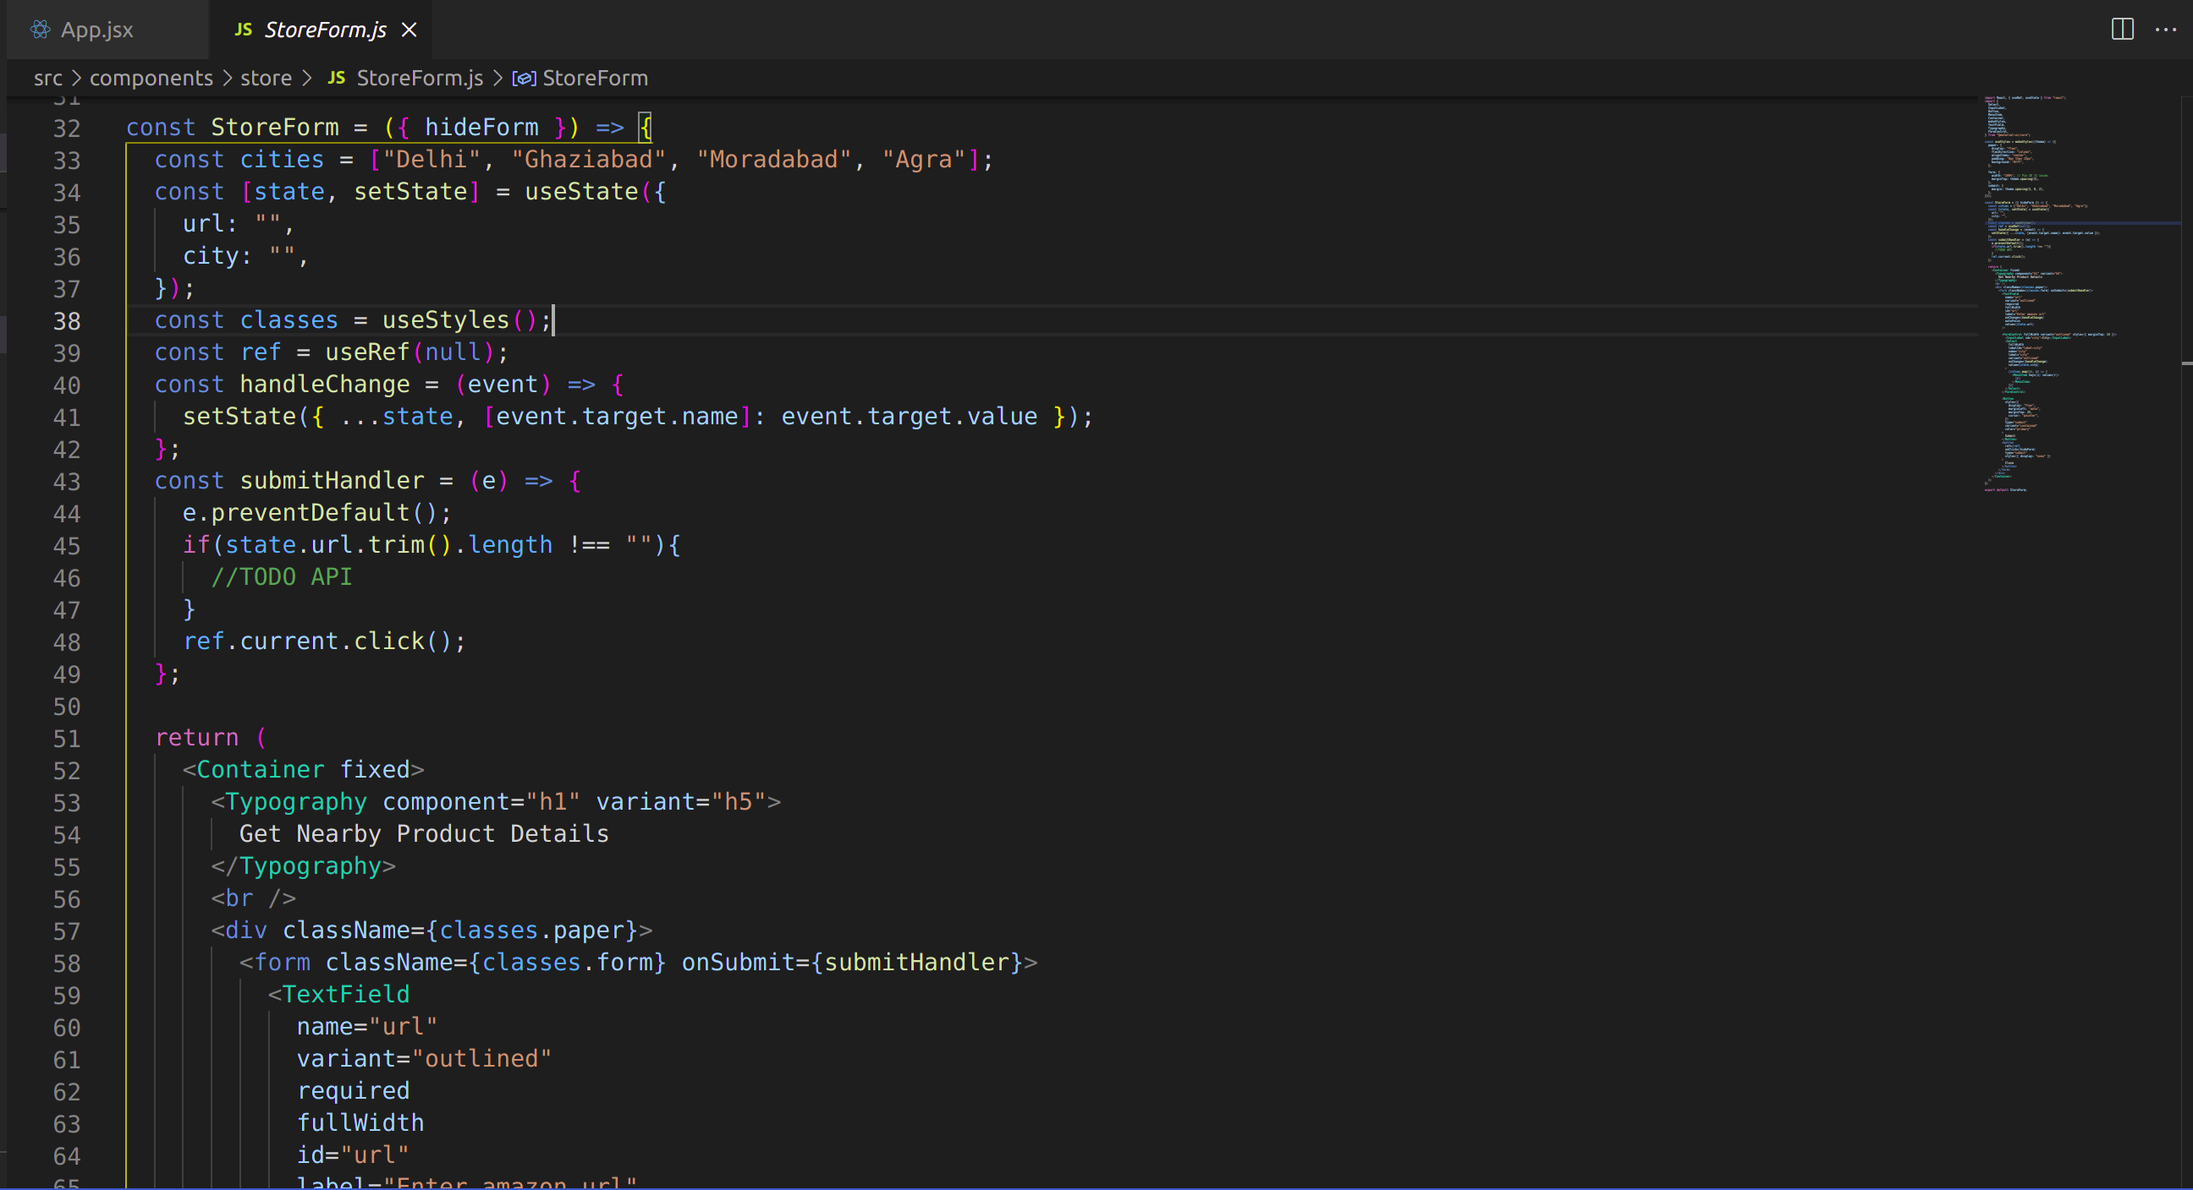

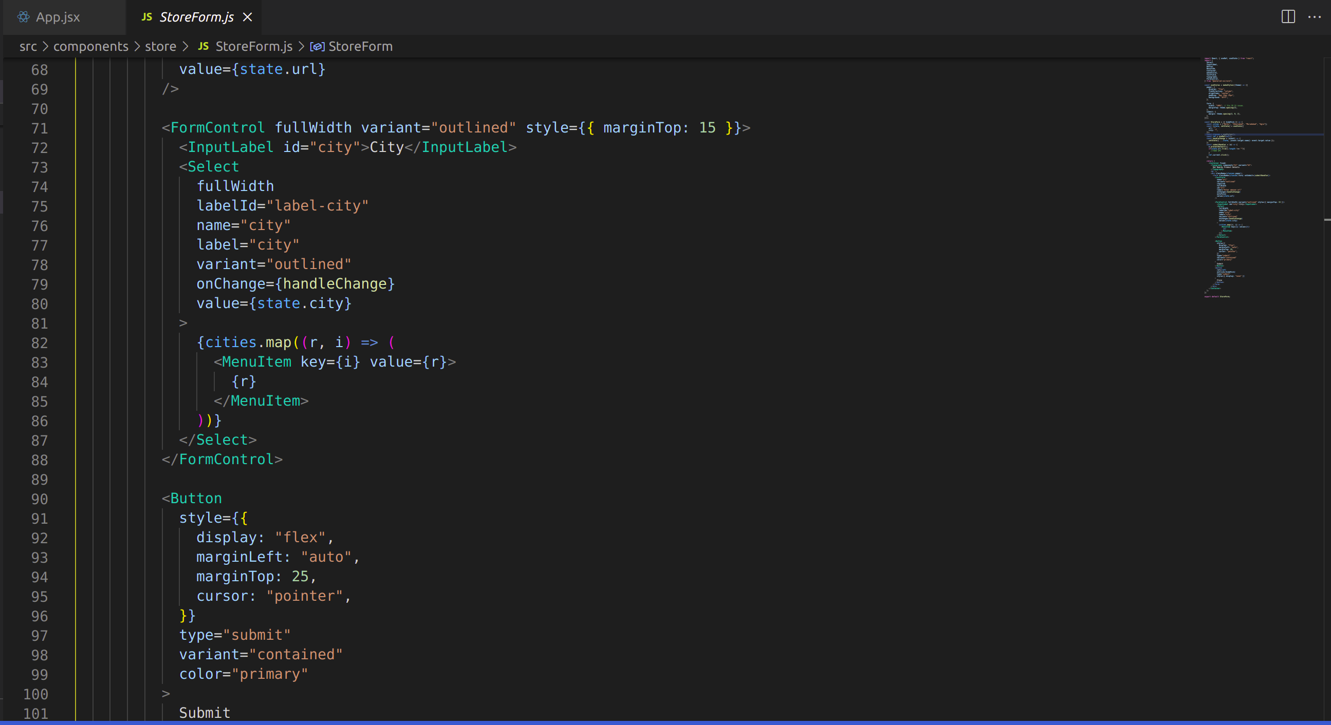

**4.4 StoreTable.js**

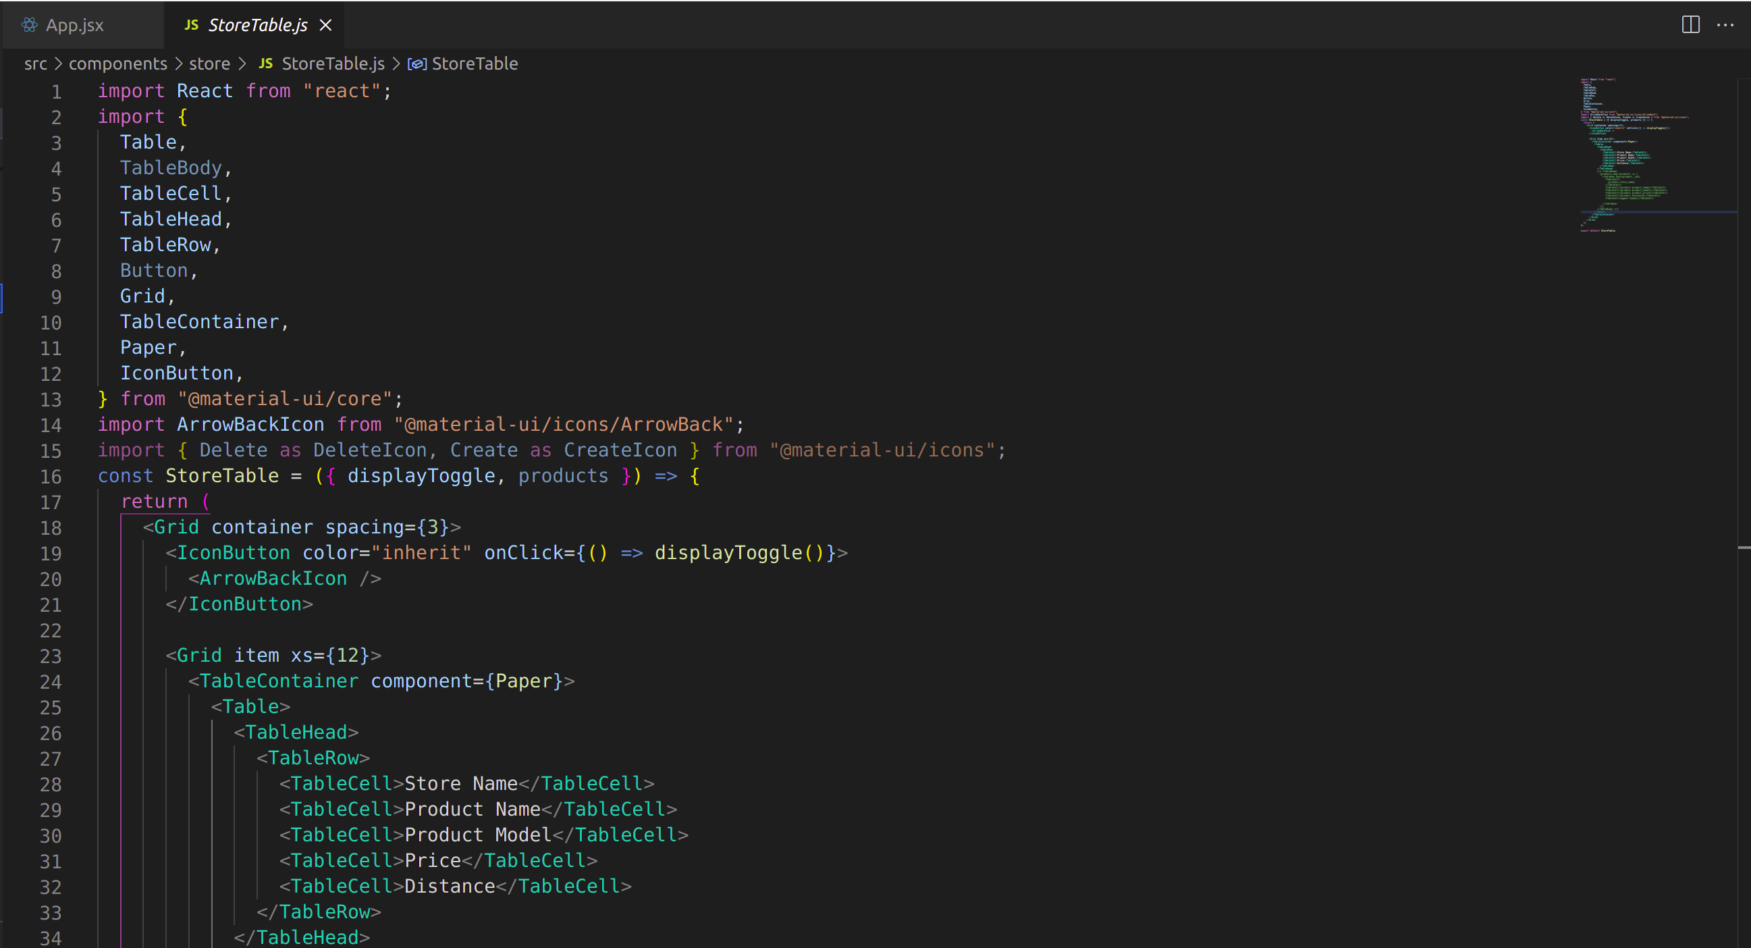

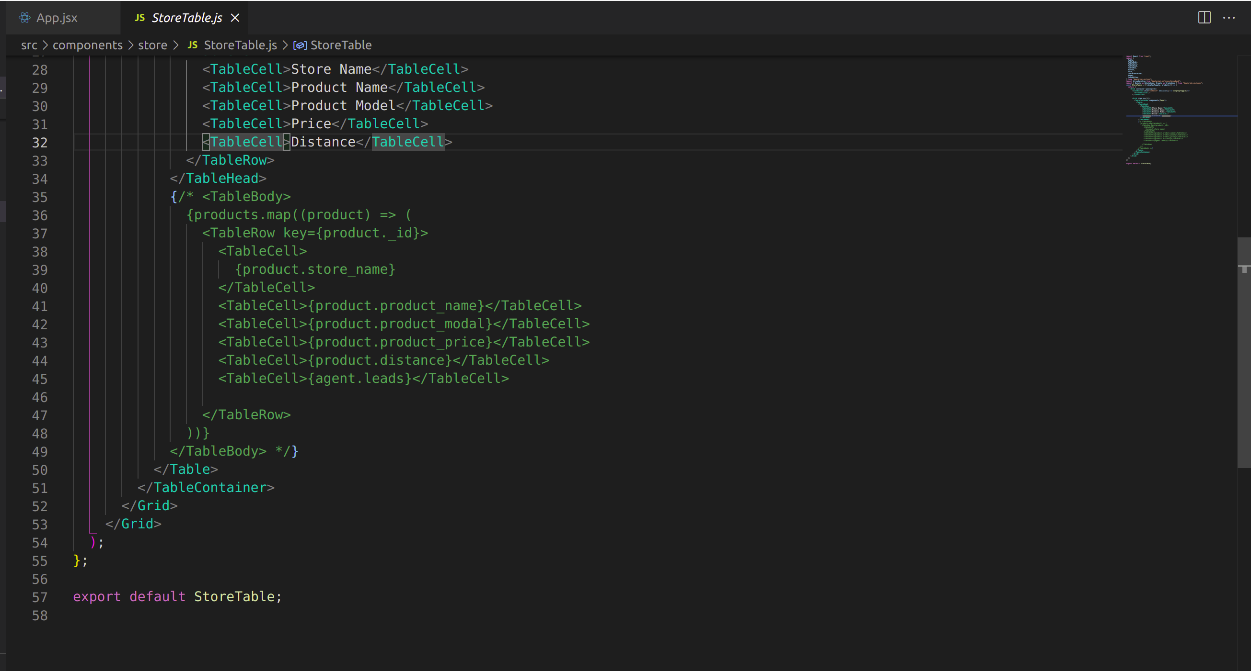



**CHAPTER 5**

**REPORT**

**5.1 Login Page**



**5.2 Product Search Channel**

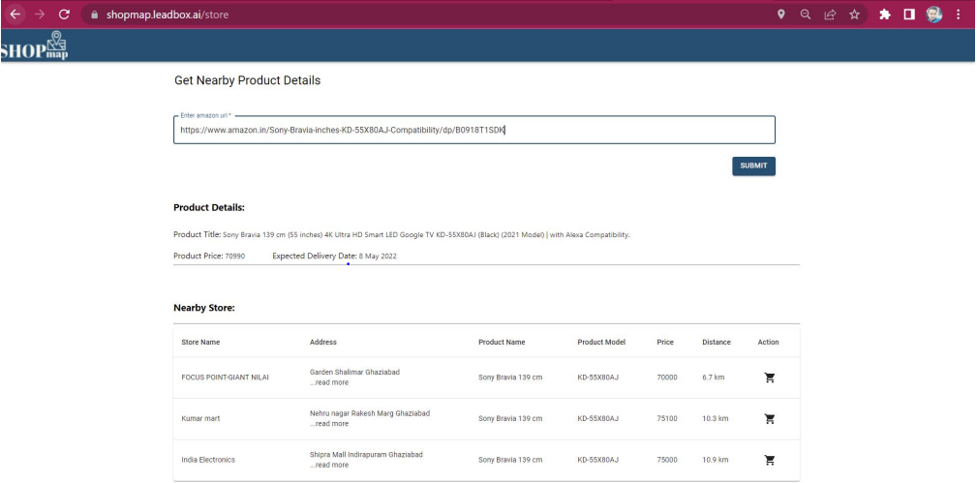

**5.3 Customer’s whats app channel**

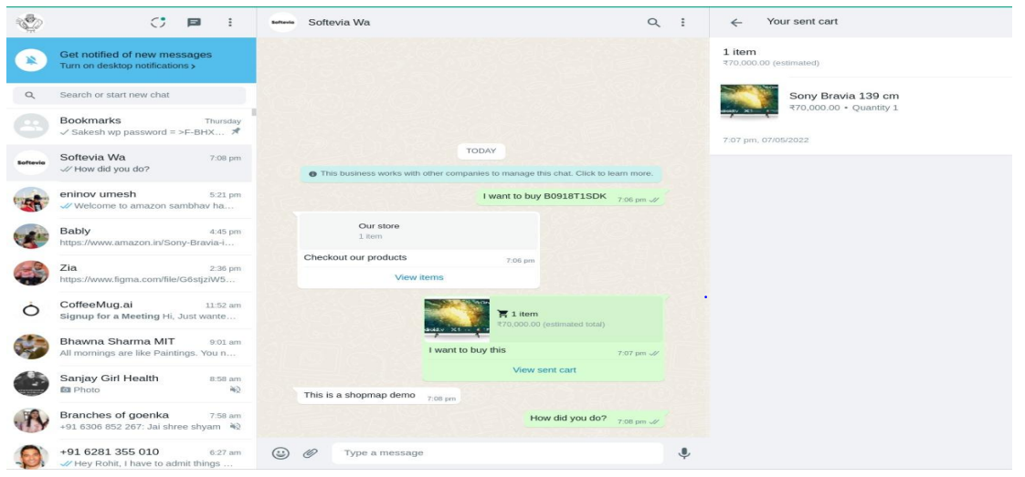

**5.4 Shop owner dashboard**

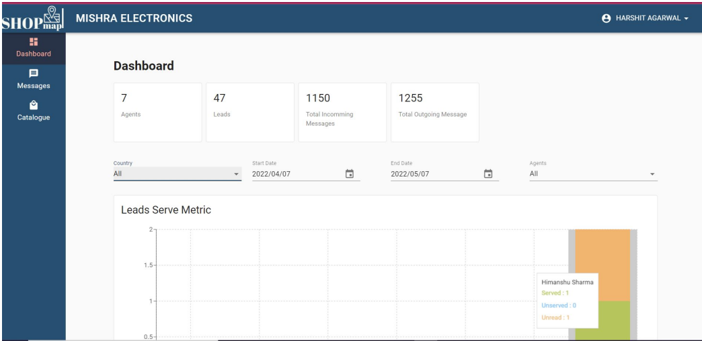

**5.5 Shop owner Customer Message Handling Channel**

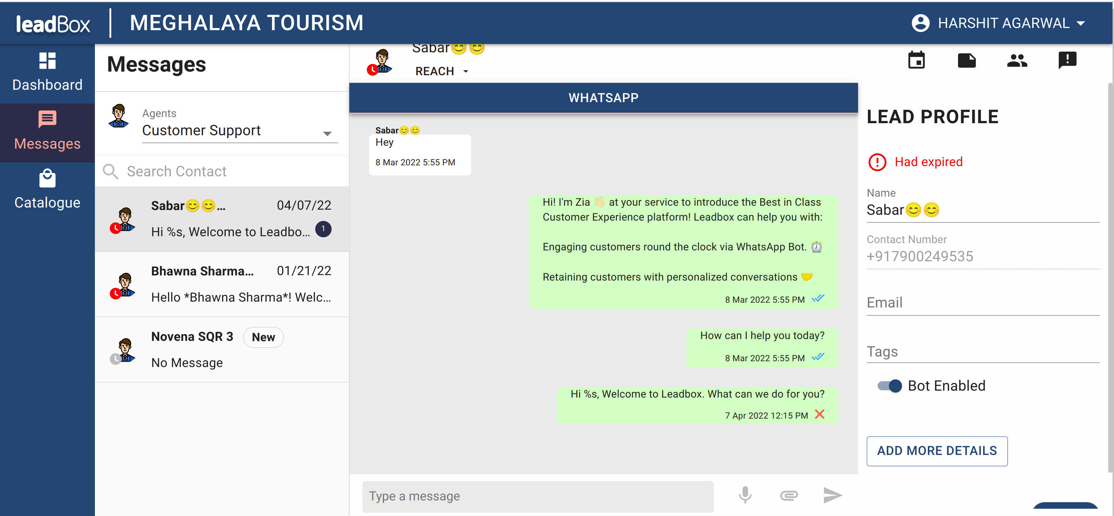

**5.6 Notes Page**

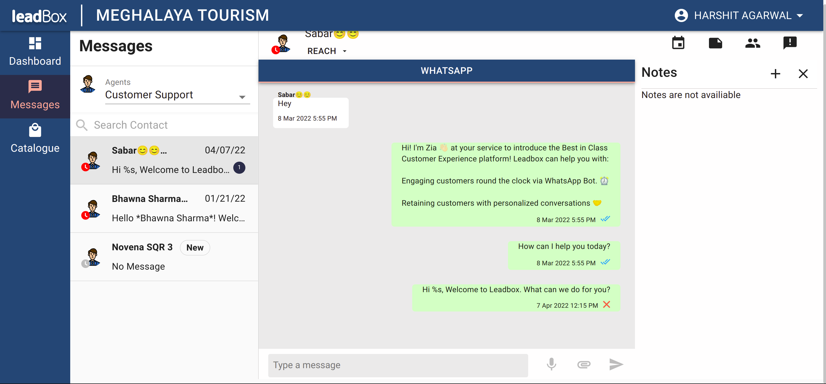

**5.7 Events Page**

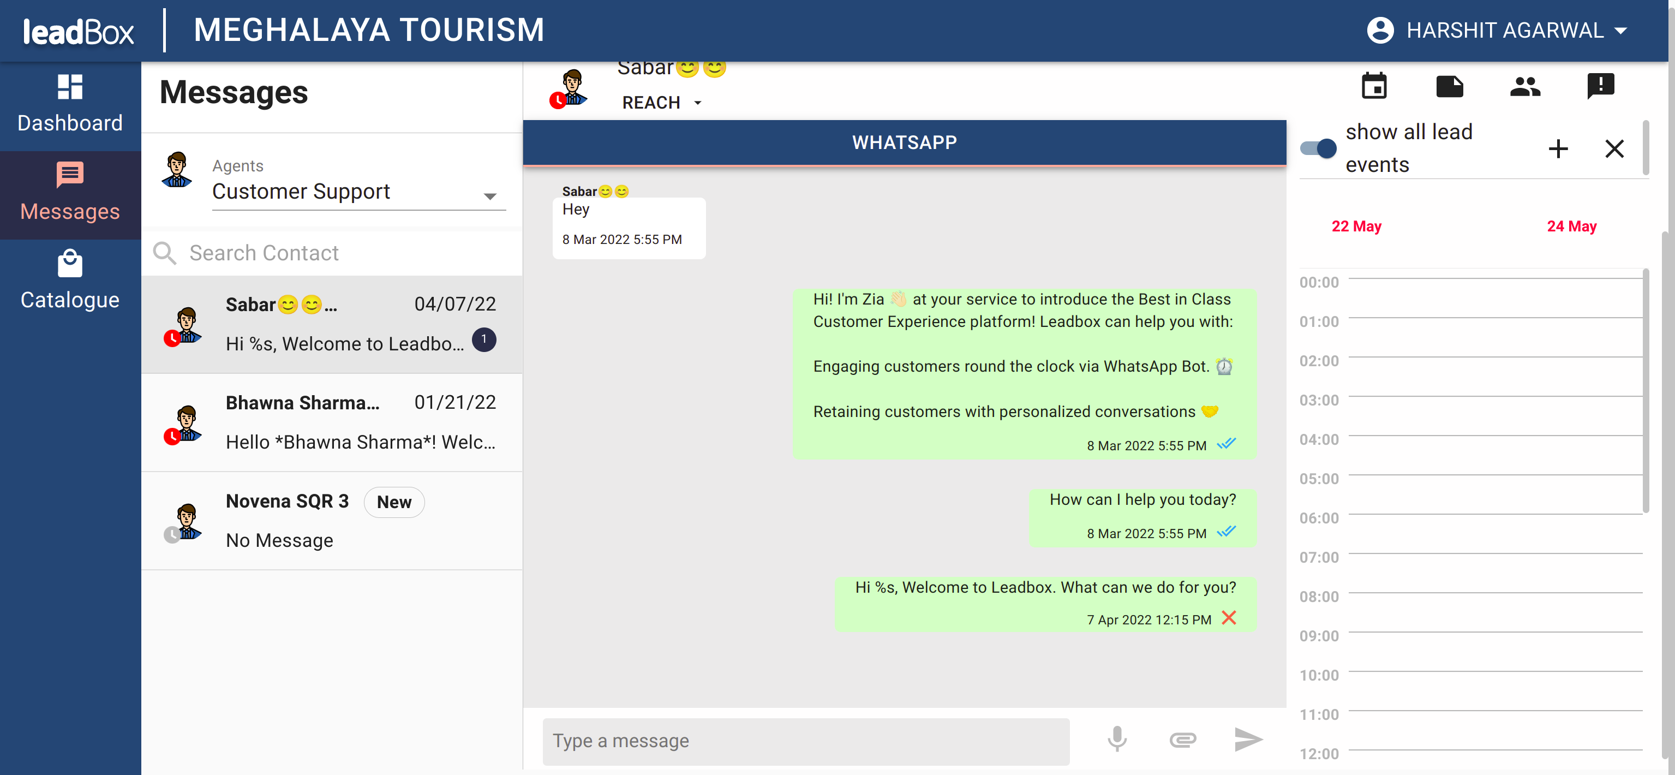

**CHAPTER 6**

**TESTING**

There are a few ways to test React components. Broadly, they divide into two categories:Rendering component trees in a simplified test environment and asserting on their output.

Running a complete app in a realistic browser environment (also known as “end-to-end” tests).This documentation section focuses on testing strategies for the first case. While full end-to-end tests can be very useful to prevent regressions to important workflows, such tests are not concerned with React components in particular, and are out of the scope of this section.

**Tradeoffs**

When choosing testing tools, it is worth considering a few tradeoffs:

Iteration speed vs Realistic environment: Some tools offer a very quick feedback loop between making a change and seeing the result, but don’t model the browser behavior precisely. Other tools might use a real browser environment, but reduce the iteration speed and are flakier on a continuous integration server.

How much to mock: With components, the distinction between a “unit” and “integration” test can be blurry. If you’re testing a form, should its test also test the buttons inside of it? Or should a button component have its own test suite? Should refactoring a button ever break the form test?

Different answers may work for different teams and products.

**Tools**

Jest is a JavaScript test runner that lets you access the DOM via jsdom. While jsdom is only an approximation of how the browser works, it is often good enough for testing React components. Jest provides a great iteration speed combined with powerful features like mocking modules and timers so you can have more control over how the code executes.

React Testing Library is a set of helpers that let you test React components without relying on their implementation details. This approach makes refactoring a breeze and also nudges you towards best practices for accessibility. Although it doesn’t provide a way to “shallowly” render a component without its children, a test runner like Jest lets you do this by mocking.

1. WebLOAD

WebLOAD is an efficient web application performance testing tools for web-hosted applications that signifies the load handling capability of the application. There is powerful scripting potential embedded in this tool that makes complex testing easy. Moreover, using this, you can also define the performance aspects, bottlenecks, and probable loopholes in your application. It is an adequate tool that can assist you in achieving the required response efficiency for your web application. In addition to that, WebLOAD is also integrated with Selenium, Jenkins, and other tools to enhance the testing power of it.

2. Acunetix

Acunetix is an automated variant web application security testing tools that is embedded with a security scanner within for detecting even the minor vulnerabilities of more than 4500 web applications. It is compatible with almost all types of web application variants such as XSS, SQL Injection, JavaScript, HTML5, and others. Moreover, it also has special features to prioritize the risks and generate reports accordingly. Not only that, but it can also integrate the test results with other tools or platforms.

3. Netsparker

Netsparker web application testing tool is renowned for its accuracy. It also has a security scanner embedded within to identify the minor and major loopholes in almost all web APIs. This tool identifies the faults and checks whether they are real or false. This will help you save time over manually checking and reviewing every identified fault after the scan. You can use the Netsparker tool either as a Windows software or as an online service provider. The features and the efficacies remain the same in either version.

4. Test IQ

Test IQ follows the ideology to help test your web applications to make it work seamlessly on all browsers or devices without any possibility of bugs and errors. The apps are tested under real-world conditions over Test IQ. This process is known as crowd testing that derives the application’s true potential and lets you know the loose ends to work on. With the right knowledge of developing and rectifying aspects, web applications can be improved to give out a high rating of user experience. Many organizations are now imposing on the efficacies of Test IQ to help make their web applications perform faster and better. Some of the additional features of Test IQ include feedbacks from real humans, faster releasing after the testing practices, and real device testing to find the core of the problems.

5. Experitest

Experitest allows the users to test web applications over 1000 devices at a time overcloud. There are both manuals as well as automated cross-browsing tools meant for testing the web applications. With Experitest, it is adequate for you to test the application on any browser. Moreover, it is integrated with Appium and Selenium for better results. The testing pattern of this tool operates in real-time and debugs it for better results. Experitest has the potential to run over 100 tests altogether in parallel. In addition to that, you can also go for visual testing to determine the efficiency of UI responsiveness over different resolutions.

6. Lambda Test

Lambda Test tool is meant for ensuring that all the web application elements such as CSS, HTML5, and others operate seamlessly on all devices. This tool follows the testing pattern of manual, visual as well as automated testing or progressive results. It uses cloud infrastructure to run multiple tests at a single time parallelly.

7. Selenium

In the list of open source automation testing tools for web applications This is the all time favorite tool of testers. Selenium is popularly known as one of the best regression testing tools that operate seamlessly over different browsers and platforms. The automation testing aspect is one of the best perks of Selenium, and there are many individual tools embedded within it. Every tool under Selenium is destined to handle different aspects of web application testing. Selenium IDE, Selenium Web Driver, Selenium RC, and Selenium Grid are the four components of Selenium.

8. Watir

Watir is the abbreviation of Web Application Testing in Ruby. The best thing about Watir is that it tests web applications in the same way as humans do. This testing tool uses ideologies such as clicking links, validating texts, form filling, and other aspects to do a real-time web application testing for identifying the major loopholes of it. It is lightweight and quite easy to use. It works seamlessly on diverse platforms or browsers.

9. Ranorex Studio

Ranorex serves the purpose of maximizing the resources to support automated testing practices. It is the right tool to commence with end-to-end testing by using simulators or real devices for more prominent results. It works fine with almost all browsers such as Safari, Microsoft Edge, Chrome, and others.

10. Serenity

Serenity testing tool makes sure that the tests are written are easier for maintenance and are quite flexible for diverse applications. Moreover, Serenity produces detailed test reports to give insight into the performance of the web application. Moreover, it also keeps a tab on all your project progress.

These are the best ten web application testing tools popularly used by [**web application companies in USA**](https://www.testrigtechnologies.com/service/web-app-testing/) for commencing on their testing aspects. With adequate results, the modification work on the applications will become easier and more convenient. The web application without any flaws will most likely give out a better user experience. For better testing solutions, you can turn up to professionals to get adequate results at the best reasonable charges.

**Test-cases Screenshots**

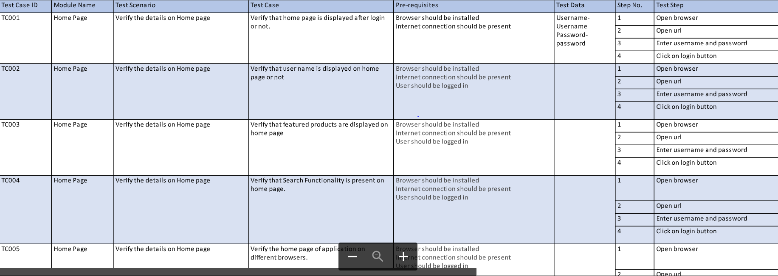

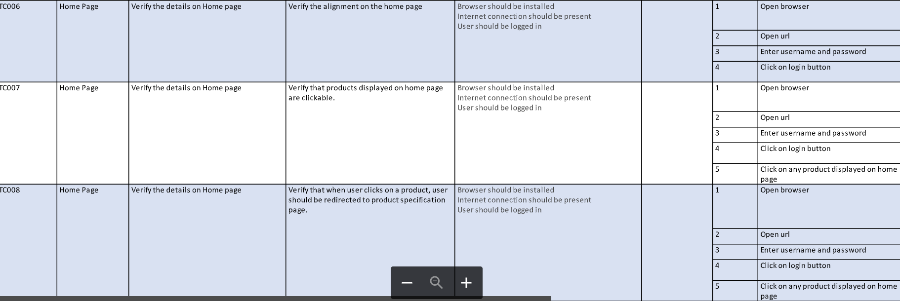

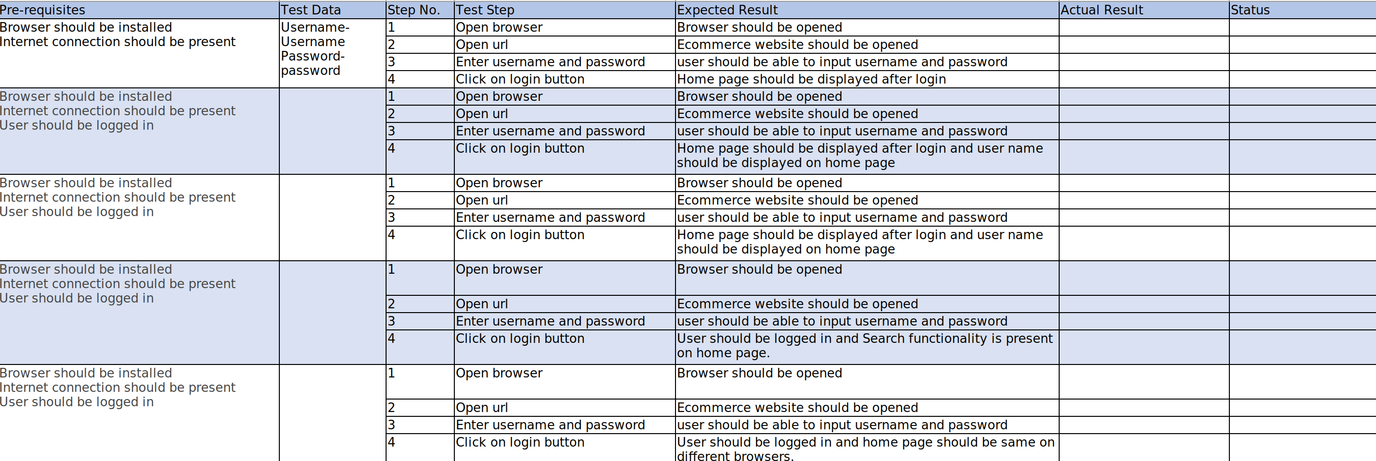

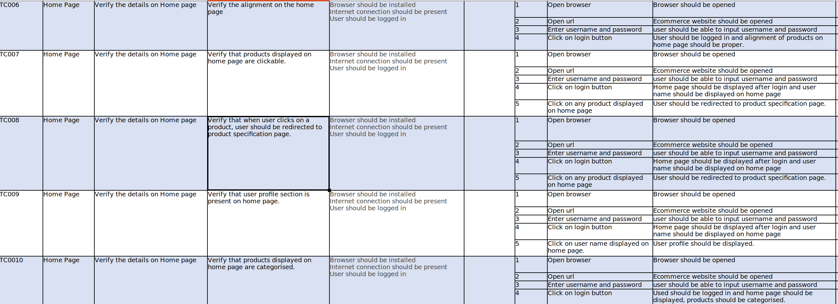

**CHAPTER 7**

**LIMITATIONS**

The project has a wide scope, as it is not intended to a particular organization. This project is going to develop generic software, which can be applied by any businesses organization. More over it provides facility to its customer. Also the software is going to provide a huge amount of summary data.

* All users can upload and share produts with their friend.
* Users can select the product category at the time of upload.
* User can also upload thumbnail.
* User can search product via category, product title and keyword.
* Administrator or management can manage the users and products.
* Admin can accept or reject the product.

**CHAPTER 8**

**CONCLUSION**

**8.1 Seamless shopping experience**

A seamless shopping experience is one that integrates customer data to personalized costumer experience and provide a continuous, connected journey as shoppers transition from one device to another, and from online to offline and back again. It puts the customer at the center of every interaction, keeps her engaged and removes friction from her path. The first step toward understanding this somewhat elusive, but endlessly important concept is to take a look at a real-life scenario.

Imagine a woman is shopping online for shoes on her mobile device while waiting in line to buy coffee in the morning. Later that day, she pulls out her tablet during lunch to continue browsing, and the retailer she is shopping with remembers where she left off, despite the device switch. Finally, when she makes it back to her desk, the shopper makes a purchase online through her desktop and picks the item up in-store that same evening.

This scenario describes the type of coherent, omnichannel experience all brands should strive for. And the fact of the matter is, customers expect this level of integration in exchange for giving brands their data and their loyalty. The following five components are crucial for achieving seamlessness at a time when the customer experience is just as important than the merchandise itself:

## 1. Informed

Businesses can’t achieve continuity without insight. To succeed, it is crucial to obtain a single view of the customer, or the ability to recognize consumer behavior, needs and interests across devices and channels by building holistic profiles. As data from Experian revealed, 97% of organizations are looking to [achieve a complete view of the customer](https://www.experian.com/blogs/marketing-forward/2016/03/22/cross-channel-marketing-plays-identify-know-engage/), but 81% of marketers struggle to achieve this end. The most crucial resource organizations must tap into to be fully informed on their customers is their own [first-party data](https://signal.co/resources/first-party-data/).

## 2. Connected

In order to recognize customers across channels and create consistency, brands must be able to collect, connect and actually act upon disparate customer data from both online and offline sources. To achieve true seamlessness, businesses must be able to connect their first-party data to each step in the customer journey, no matter how many times consumers switch devices or channels

## 3. Fast

It is fairly well-known how often consumers switch devices. According to Criteo, 40% of e-commerce transactions along the path to purchase. But marketers also need to be prepared for how quickly they transition from one platform to the next. To really stitch together their marketing and online experiences, brands must have the ability to connect first-party data, recognize consumers across channels and personalize as quickly as their customers switch from desktops to tablets and between in-store and devices.

## 4. Personalized

Every step in a truly harmonious customer experience is personalized to that individual’s preferences, past shopping behavior and other touchpoints such as call center interactions. In fact, eMarketer shared research that found 81% of consumers want their online shopping expandable to be easy, customized and relevant.

Consider a customer who purchases an airline ticket on his phone. When he logs onto the airline’s website through his tablet, the site is immediately personalized with recommendations that are relevant to both his past and upcoming travel plans, such as discounts on car rentals from his favorite brand or customized recommendations based on his travel interests.

Seamlessness can go even further than that, though. Imagine this particular customer arrives at the airport to find his flight has been canceled. Rather waiting in line to speak to an agent, he can log on through his smart phone and the app will already recognize his situation and give him options to rebook quickly.

## 5. Device Optimized

Finally, if a business hopes to create truly continuous, omnichannel shopping experiences, it is crucial that its digital properties are optimized for varying devices spanning from smart phones to tablets and desktop computers. According to Adobe, [39% of people will stop engaging with a website](https://blogs.adobe.com/creative/files/2015/12/Adobe-State-of-Content-Report.pdf) if images won’t load or take too long to load. No matter the device or channel, consumers should expect a consistent browsing experience.

Businesses that adopt consistent, omnichannel strategies stand to win in the Age of the Experience. According to data from Aspect, organizations that do so achieve 91% greater rates than those that do not. And these five components considered, it only makes sense for organizations to turn to people-based marketing, a strategy that is truly informed, connected, fast and personalized. The result is brands that are empowered to create seamless experiences and more addressable media campaigns that are not limited by device or channel.

**8.2 Marketing capability for Shop Owners - Broadcast campaign**

Local store marketing—sometimes known as neighborhood marketing—describes the combination of strategies used to target customers within a specific area. This area is typically no more than a 5-mile radius around your physical store, as the goal of LSM is more so connecting with the community than achieving a broad reach.

When planning an LSM strategy, business owners are challenged with identifying what makes their local community unique. It requires a strong understanding of the people who live in your surrounding neighborhood(s), so you can cater your messages directly to them and increase sales.

Though LSM is frequently used by small businesses, it’s also an incredibly effective technique for franchisees and large-scale businesses with [brick-and-mortar](https://vanbrunt.wpengine.com/article/brick-and-mortar/) stores. By reaching out to potential customers on a local level, your message becomes far more personalized. This can not only help you gain more foot traffic, but it will also help you gain

who see you as a critical part of the community and [spend 67% more](https://blog.fivestars.com/5-ways-to-increase-customer-loyalty/) than first-time visitors.

## local store marketing strategies

Building an effective local store marketing plan requires you to blend your hyper-local market research with strategies that help you build relationships, rather than just expand your reach. In doing so, you can build a brand that your audience can fully relate to and they [become loyal customers](https://vanbrunt.wpengine.com/article/relationship-marketing/).

We’ll introduce you to some strategies you can use to boost your local marketing efforts and community presence below.

### 8.2.1 Engage on social media

Storefront signage may be able to draw in some new customers, but odds are, your audience is spending more time online than passing by your local store. With most internet users using social media for [over two hours per day](https://www.statista.com/statistics/433871/daily-social-media-usage-worldwide/), social platforms provide endless opportunities to engage directly with consumers in your area.

Keeping an active social media presence for your local store or stores gives community members the opportunity to reach out to you, even when they’re not directly in your area. As you respond more, your customer engagement will rise and loyal followers may become loyal in-store shoppers, too.

Social media ads are also great tools for targeting customers in specific areas with localized content, so you can engage more with potential customers outside of your direct following.

Some businesses may even find it useful to create Facebook groups for their local customer base. As long as you have a team member who can serve as a strong moderator, this is a great way to prove that you’re a leader in fostering community while providing value to locals.

### 8.2.2 Create a customer loyalty program

Reengaging shoppers is extremely important in local store marketing. To compete with the modern convenience of ecommerce stores, you need to provide ongoing value that drives customers back to your physical location after their first visit. Customer loyalty programs can effectively make this happen.

As much as [77% of consumers](../Desktop/EmployeePerformanceSystem_Group_6/_blank) will take part in loyalty programs. To encourage them to do so, you need to provide ongoing rewards that show them they can get more value out of shopping with you than any other brand. Examples of great reward systems may include:

A coffee shop offering a free drink once every 10 visits

An auto repair shop offering a discounted service once every five oil changes

A grocery store with a tiered loyalty system that allows customers to increase ranks and get better freebies the more they spend

### 8.2.3 Collaborate with locals

Collaborating with local businesses and entrepreneurs is an excellent way to cultivate brand awareness within existing customer bases. Not only do local collaborations show your commitment to lifting up your community first, but they also help you instantly build trust.

Collaborations can take many forms. A local bakery and ice cream parlor may work together to create a limited edition dessert. A gym and med spa may partner on a social media giveaway. Professionals in the wedding industry often just cross-promote on each other’s websites.

Of course, you still want to be strategic about who you’re working with. The most valuable collaborations occur when you work with trusted local brands that share your core values, target similar audiences, and can provide consistent referrals to your business. For example, it would make much more sense for a luxury hair salon to partner with a high-end nail salon than a budget tattoo parlor, even though both options fall under the beauty industry.

Your city’s chamber of commerce can be a great resource as you’re looking for like-minded brands to collaborate with.

### 8.2.4 Take part in local events

Your potential customers don’t want you to just say you’re invested in the community—they want you to show it. Showing up at community events, including both nonprofit and for-profit ones, can be a great local store marketing opportunity for you.

When you have a booth at or simply talk to people at local events, you allow people to connect your face to your brand, making your company feel much more human. In fact, [84% of business leaders](../Desktop/EmployeePerformanceSystem_Group_6/_blank) attribute a significant part of their brand’s success to event marketing. The power of face-to-face connections is still unmatched when it comes to neighborhood marketing.

Sponsoring events can further show your financial investment in the community outside of your brand. It can also be a great alternative to a physical presence at an event when your team has limited time to spare.

### 8.2.5 Reach out to local press

The [majority of Americans](https://www.statista.com/statistics/707507/national-local-news-trust/) trust their local news outlets to tell the truth. This high level of trust means that gaining positive press coverage—which can reach thousands of local customers—can drive an enormous amount of foot traffic to your store.

A large part of gaining press coverage is sending out press releases whenever your business has something noteworthy (or appealing to a mass audience) to report. However, building relationships with your local journalists can have the greatest impact in the long term, as you’ll continuously be considered for local listicles, expert quotes, and other online mentions.

The more frequently your site is mentioned and linked on news sites, which typically have strong page authority on Google, the higher your [search engine rank](https://vanbrunt.wpengine.com/article/local-seo-strategy/) can be for relevant local searches.

## 8.2.6 Lead your local area

Great local store marketing strategies are essential for any company with a brick-and-mortar store. While it requires quite a bit of market research and commitment, the results can be far superior to those you’d get through general marketing techniques. As you boost your community presence and become a staple part of local customers’ lives, your business will be more sustainable and experience improvements to your bottom line.

As you continue mastering neighborhood marketing, you can start pairing your localized marketing efforts with enhanced relationship-building techniques to drive further loyalty. Get our [relationship marketing tips](https://vanbrunt.wpengine.com/article/relationship-marketing/) to create the strong customer base you need.

**8.3 Personal Shopping assistant**

Digital marketplaces like eBay, Amazon, Asos, etc. make online shopping convenient, fast and personalized. People spend millions of dollars online and they tend to go mobile when searching for new outfits. To prove our point we have looked for a recent statistics and managed to discover that while people from all over the world still make more orders via desktops, the larger amount of traffic comes from mobile devices, see

So taking into account this statistics we can say, that mobile personal shopping apps have a huge potential if you add a handy set of features, categorize everything in the app properly, and incorporate convenient [payment method](https://gbksoft.com/blog/best-payment-gateway-systems-for-your-online-business/). Personal shopping apps are rather new niche and there is still a place for innovation. So if you want to enter the market with a new application, this might be a perfect option for you. This investment will definitely pay itself off.

Building a personal shopper app might bring new experience to the consumer market and enhance people lives with such scarce resource as time. But this is not the only one benefit of such solutions. Let’s speak about others even more exciting. 

8.3.1 Benefits of Personal Shopping Assistant App

It is not a secret that customers like great and fast service. And now with the outbreak of pandemic they prefer not to leave the house and purchase everything online. So if you have a local store, showroom or just a department in a huge mall, it is time to think about personal shopping app. To have social media account and sell clothes on them is not enough. People need something better, that has more advantages. And among ones offered by personal shopping app you’ll see the following:

### 8.3.1.1 It saves time and money

Online shopping might be fun but it can also be time-killer. You may still get hundreds of products, even when you have put a filter to find the black dress under $100 in a digital store. Why spend hours searching for the ideal dress when you can simply tell your personal shopping assistant to do it for you? And what if you could replace full-time employee (who requires a salary) with an automated technology? It’s definitely a win win solution!

### 8.3.1.2 It finds the best deals

Shopping assistant apps go far beyond simple price comparison. Add an item to favorites and wait until the app alarms you that desirable product is on sale. Such shopping application can obtain data from both retailers and online stores to inform users of best deals, sales, special

bonuses or discounts. The main idea of virtual shopping assistant is to save your money instead of making you spend more on unnecessary services.

You’ve probably heard about the– an AI-powered personal shopping assistant. It is such a handy solution that it does all the job for the customers. It helps you find the best possible price various promotions

### 8.3.1.3 It keeps shopping records in one place

Shopping assistant app keeps all the purchases organized so you can review the shopping list anytime. An app constantly tracks transactions to make it easier to control spendings. Quite a handy feature for shopaholics, isn’t it? With personal shopping assistant you don’t need to worry about saving checks or else.

### 8.3.1.4 It makes your shopping personalized

Modern marketplaces usually offer us trending goods or similar to those that we’ve reviewed. But such propositions may not fit your body type or the occasion you buying it for. However, the more time you use personal shopping assistant app, the more information about your preferences it collects, learns and, thus, gives you more personalized recommendations. Over time, built-in artificial intelligence will understand your preferences better and guesses your needs like an old friend.

Generally, shopping assistant apps are powered by pure Machine Learning or combine AI with real humans guidance. That means a real-time check of data proposed by intelligent assistant by human admins. In the meantime, thanks to computer learning and smart algorithms, apps can learn and analyze human tips and provide users with better shopping experience.

Below we’ll briefly list the most common features that you should consider before building your own personal shopping assistant app

**CHAPTER 9**

**REFERENCES**

1. Lucio Grandinetti, Seyedeh Leili Mirtaheri, Reza Shahbazian (Eds.), High-Performance Computing and Big Data Analysis, Second International Congress,TopHPC 2019 Tehran, Iran, April 23–25, 2019 Revised Selected Papers, Springer.
2. Becken, S., Alaei, A. R., & Wang, Y. (2019). Benefits and pitfalls of using tweets to assess destination sentiment. Journal of Hospitality and Tourism Technology.
3. Zongben Xu, Xinbo Gao, Qiguang Miao, Yunquan Zhang, Jiajun Bu (Eds.)., Big Data, 6th CCF Conference, Big Data 2018 Xi’an, China, October 11–13, 2018 Proceedings,Springer.
4. T. A. Ashwitha, A. P. Rodrigues and N. N. Chiplunkar, "Movie Dataset Analysis Using Hadoop-Hive," 2017 2nd International Conference on Computational Systems and Information Technology for Sustainable Solution (CSITSS), 2017, pp. 1-5, doi:
5. Kune, R., Konugurthi, P. K., Agarwal, A., Chillarige, R. R., & Buyya, R. (2016). The anatomy of big data computing. Software: Practice and Experience, 46(1), 79-105.
6. Wang, J., Xu, C., Zhang, J., & Zhong, R. (2021). Big data analytics for intelligent manufacturing systems: A review. Journal of Manufacturing Systems.
7. Costa, R. L. D. C., Moreira, J., Pintor, P., dos Santos, V., & Lifschitz, S. (2021). A Survey on Data-driven Performance Tuning for Big Data Analytics Platforms. Big Data Research, 25, 100206.
8. Uzunkaya, C., Ensari, T., & Kavurucu, Y. (2015). Hadoop ecosystem and its analysis on tweets. Procedia-Social and Behavioral Sciences, 195, 1890-1897.
9. Mohammed M. Alani, Hissam Tawfik, Mohammed Saeed, Obinna Anya, Applications of Big Data Analytics, Trends, Issues, and Challenges, Springer. 5112. Zhai, Y., Tchaye-Kondi, J., Lin, K. J., Zhu, L., Tao, W., Du, X., & Guizani, M. (2021). Hadoop Perfect File: A fast and memory-efficient metadata access archive file to face small files problem in HDFS. Journal of Parallel and Distributed Computing.
10. FEI HU, Big Data Sharing Storage and Security, CRC Press Taylor & Francis Group.
11. Kalia, K., & Gupta, N. (2020). Analysis of hadoop MapReduce scheduling in heterogeneous environment. Ain Shams Engineering Journal.
12. Ashwitha T AAnisha P Rodrigues Niranjan N Chiplunkar, Movie Dataset Analysis using Hadoop-Hive.
13. Lucas Filho, E. R., de Almeida, E. C., Scherzinger, S., & Herodotou, H. (2021). Investigating Automatic Parameter Tuning for SQL-on-Hadoop Systems. Big Data Research, 25, 100204.
14. Ammar Fuad, Alva Erwin, Henru Purnomo Ipung, Processing Performance on Apache Pig, Apache Hive and MySQL Cluster, IEEE, 2014 International Conference on Information, Communication Technology and System.
15. Shujia Zhou et al., Visualization and Diagnosis of Earth Science Data through Hadoop and Spark, 978- 1-4673-9005-7/16/2016 IEEE International Conference on Big Data.
16. Karan Sachdeva et al., Comparison of Data Processing Tools in Hadoop, IEEE, 2016.
17. International Conference on Electrical, Electronics,Communication, Computer and Optimization Techniques.
18. Aditya Bhardwaj et al., Big Data Emerging Technologies: A CAseStudy with Analyzi Twitter Data using Apache Hive, IEEE, 2015 RAECS UIET Panjab University Chandigarh